Self-Reflection Tool on Partnerships in Education
Learners
European Agency for Special Needs and Inclusive Education

The European Agency for Special Needs and Inclusive Education (EASNIE) is an independent and self-governing organisation. EASNIE is co-funded by the ministries of education in its member countries and by the European Commission via an operating grant within the European Union (EU) education programme.

Funded by the European Union. Views and opinions expressed are however those of the author(s) only and do not necessarily reflect those of the European Union or the European Commission. Neither the European Union nor the European Commission can be held responsible for them.

The views expressed by any individual in this document do not necessarily represent the official views of EASNIE, its member countries or the European Commission.
© European Agency for Special Needs and Inclusive Education 2025
Editors: Pamela Zoe Topalli, Antonella Mangiaracina and Katherina Alvarez
This publication is an open-source resource. This means you are free to access, use, modify and disseminate it with appropriate credit to the European Agency for Special Needs and Inclusive Education. Please refer to EASNIE’s Open Access Policy for more information: www.european-agency.org/open-access-policy.
You may cite this publication as follows: European Agency for Special Needs and Inclusive Education, 2025. Self-Reflection Tool on Partnerships in Education: Learners. (P. Z. Topalli, A. Mangiaracina and K. Alvarez, eds.). Odense, Denmark


This work is licensed under a Creative Commons Attribution-NonCommercial-ShareAlike 4.0 International License.
You are free to share and adapt this publication.
With a view to greater accessibility, this report is available in accessible electronic format on EASNIE’s website: www.european-agency.org

Secretariat
Østre Stationsvej 33
DK-5000 Odense C Denmark
Tel.: +45 64 41 00 20
secretariat@european-agency.org
Brussels Office
Rue Montoyer 21
BE-1000 Brussels Belgium
Tel.: +32 2 213 62 80
brussels.office@european-agency.org

Contents
Self-reflection tool on partnerships in education 4
Purpose 4
How the tool is organised 5
Using the tool 7
Using the developmental scale 7
Reflection process 7
Key principles 7
Learners’ level 9
Area 1: Knowing our rights and how school decisions are made 10
Goal 1.1: Learners know they have a right to be listened to and to take part in decisions about their education 10
Goal 1.2: Schools explain clearly how learners can share ideas, give feedback or ask questions about school life 11
Area 2: Having a say in school life 12
Goal 2.1: Learners have regular chances to share ideas about school life and learning 12
Goal 2.2: Learners see that their ideas are taken seriously and can lead to change 13
Area 3: Feeling supported to take part 14
Goal 3.1: All learners have fair chances to join activities, councils or discussions that shape school life 14
Goal 3.2: Schools help learners build the skills and confidence to share ideas respectfully and clearly 15
Area 4: Sharing feedback and seeing change 16
Goal 4.1: Learners can give honest feedback about their learning and school experiences 16
Goal 4.2: Schools let learners know what changed because of their feedback 17
Area 5: Learning together 18
Goal 5.1: Learners take part in activities that build teamwork, empathy and shared
learning 18
Goal 5.2: Learners and adults learn from one another about how to make learning more inclusive 19
Area 6: Belonging, care and working together 20
Goal 6.1: Learners feel they belong at school and can ask for help when they need it 20
Goal 6.2: Learners take part in school or community actions that care for others and improve their shared environment 21

Self-reflection tool on partnerships in education

Purpose
This self-reflection tool helps decision-makers, schools, communities, families and learners explore how partnerships currently work in practice and how to strengthen them. It supports users to recognise strengths, identify gaps and plan realistic next steps across six partnership areas.
It is an output from the Learners and Families Shaping Action (LFSA) activity, conducted by the European Agency for Special Needs and Inclusive Education (EASNIE).
The tool has five sections, one for each group of partners. While sections are organised by partner group, the tool should be used collaboratively wherever possible, with different perspectives informing reflection on the same areas. All five sections and the accompanying Guidance and Methodology Report are available on:
www.european-agency.org/resources/publications/LFSA-tool.
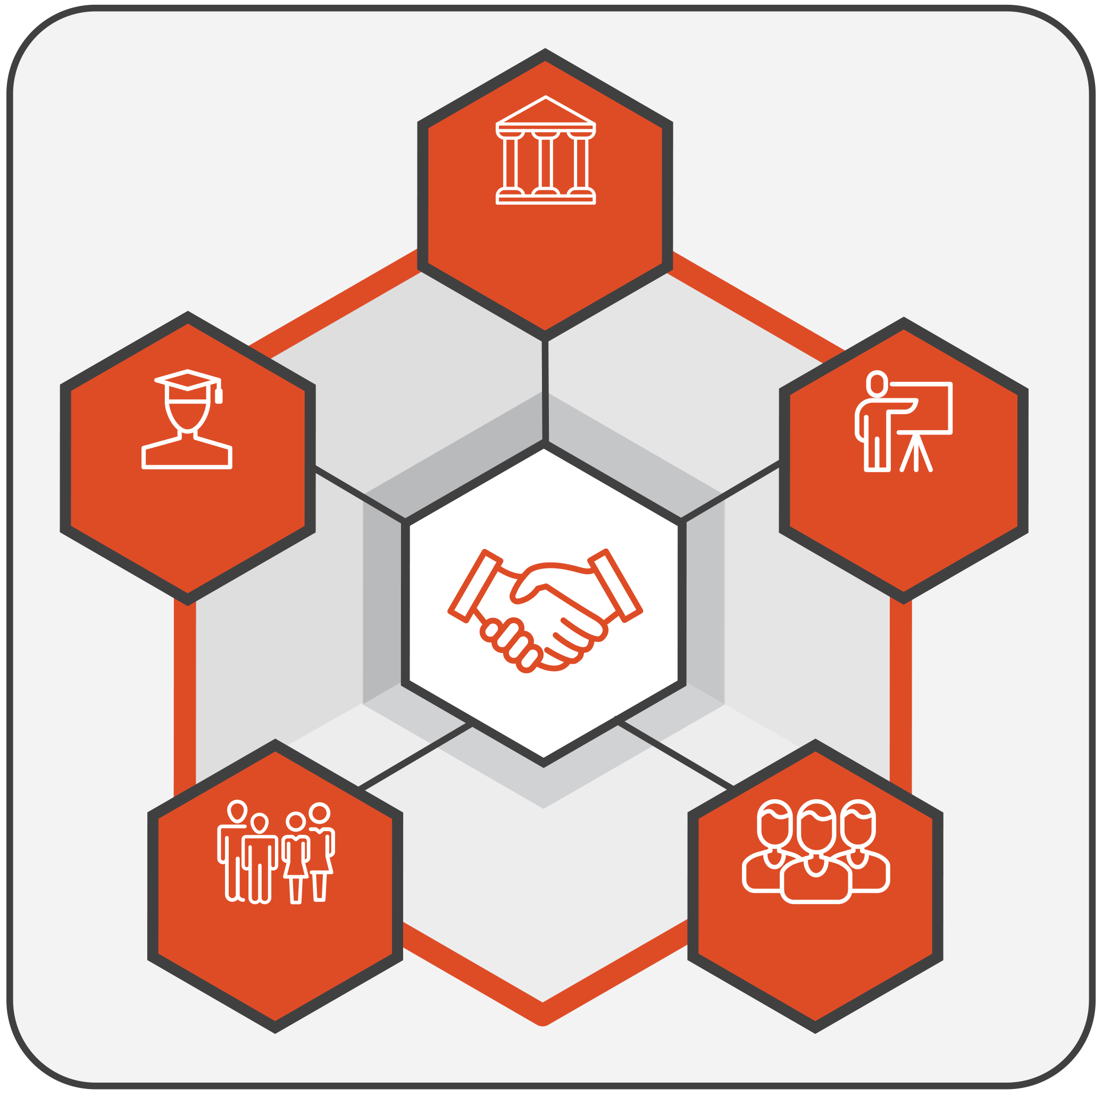
DECISION-MAKERS
LEARNERS
FAMILIES
SCHOOLS
COMMUNITIES
Figure 1. Partners

How the tool is organised
The tool has a dedicated section for each specific group of partners (decision-makers, schools, community, families, learners). Each section has the following structure:
- Area: The broad domain or theme for reflection (for example, legislation, governance, resources).
- Goal: The specific aim or expected outcome for that area.
- Guiding questions: Focused questions designed to prompt reflection and dialogue.
- Prompt(s): Optional cues that help you think more concretely about the question (for example, ‘Are there feedback channels to families?’, ‘Is learner input reflected in policy?’). Prompts aim to help guide deeper discussion.
- Current status: A four-point developmental scale showing where practice currently stands:
  - 0 = Not developed: No structures or processes in place.
  - 1 = Initiated: Early steps that often depend on individual commitment, short-term projects or specific contexts, and are not yet embedded in formal structures, procedures or resourcing.
  - 2 = Developing: Practices are becoming more coherent, responsibilities are clearer and less dependent on individual actors, and implementation is expanding across contexts. However, consistency, sustainability or system-wide reach are not yet fully ensured.
  - 3 = Established: Partnership is fully integrated, regularly reviewed and used to inform improvement.
- Comments/evidence: Short notes or examples supporting your reflection (for example, reference to a national policy, school strategy, meeting record or evaluation report). These can include both policy evidence (frameworks, regulations or formal commitments) and practice evidence (documents, actions or data showing implementation). Where relevant, you may wish to mention the source or context briefly to help track progress over time.
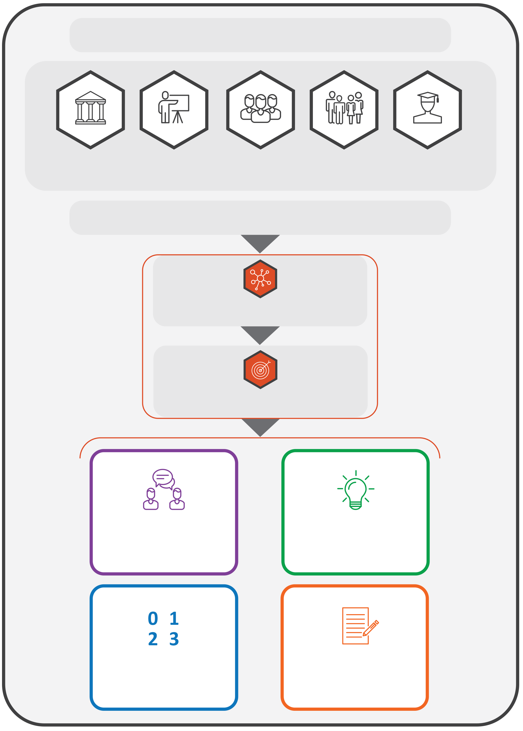
THE TOOL HAS A SECTION FOR EACH GROUP OF PARTNERS

DECISION-MAKERS
LEARNERS
FAMILIES
SCHOOLS
COMMUNITIES
EACH SECTION IS STRUCTURED AS FOLLOWS:
AREA
GOAL
GUIDING QUESTIONS
CURRENT STATUS
PROMPTS
COMMENTS/ EVIDENCE
Figure 2. Structure of the tool

Using the tool
The tool can be used to:
- support internal reflection within ministries, departments and schools;
- structure dialogue between decision-makers and partners;
- inform policy review, strategy development or funding design;
- complement existing monitoring, evaluation or peer-learning processes.

Using the developmental scale
The 0–3 scale is not for comparison or ranking. It helps users to consider where they are now and to identify realistic next steps for growth. It shows how well partnership is included in everyday practice, rather than treated as a one-off activity.

Reflection process
- Review each area and the guiding questions.
- Discuss and agree on a rating (0–3) based on the available information.
- Enter short examples or notes in the ‘Comments/evidence’ column.
- Identify two or three concrete next steps for improvement.
- Revisit periodically (for example, once a year) to monitor change and share learning.
You may choose to reflect on all six areas or focus on those most relevant to your current priorities. The tool is designed to be flexible: you may adapt the sections, questions or language to fit your context and capacity.

Key principles
- Developmental, not evaluative: The tool supports learning and improvement, not inspection.
- Collaborative: Reflection should, whenever possible, bring together multiple perspectives.
- Inclusive: All partners (decision-makers, schools, communities, families and learners) contribute to partnership quality.
- Flexible: The tool can be used in full or in part, depending on purpose and timing. Countries, regions or institutions may combine or simplify questions, focus on selected areas or adapt the format to align with national processes and capacity. It can serve as a stand-alone reflection activity, part of a peer-learning exchange or input for national reviews.
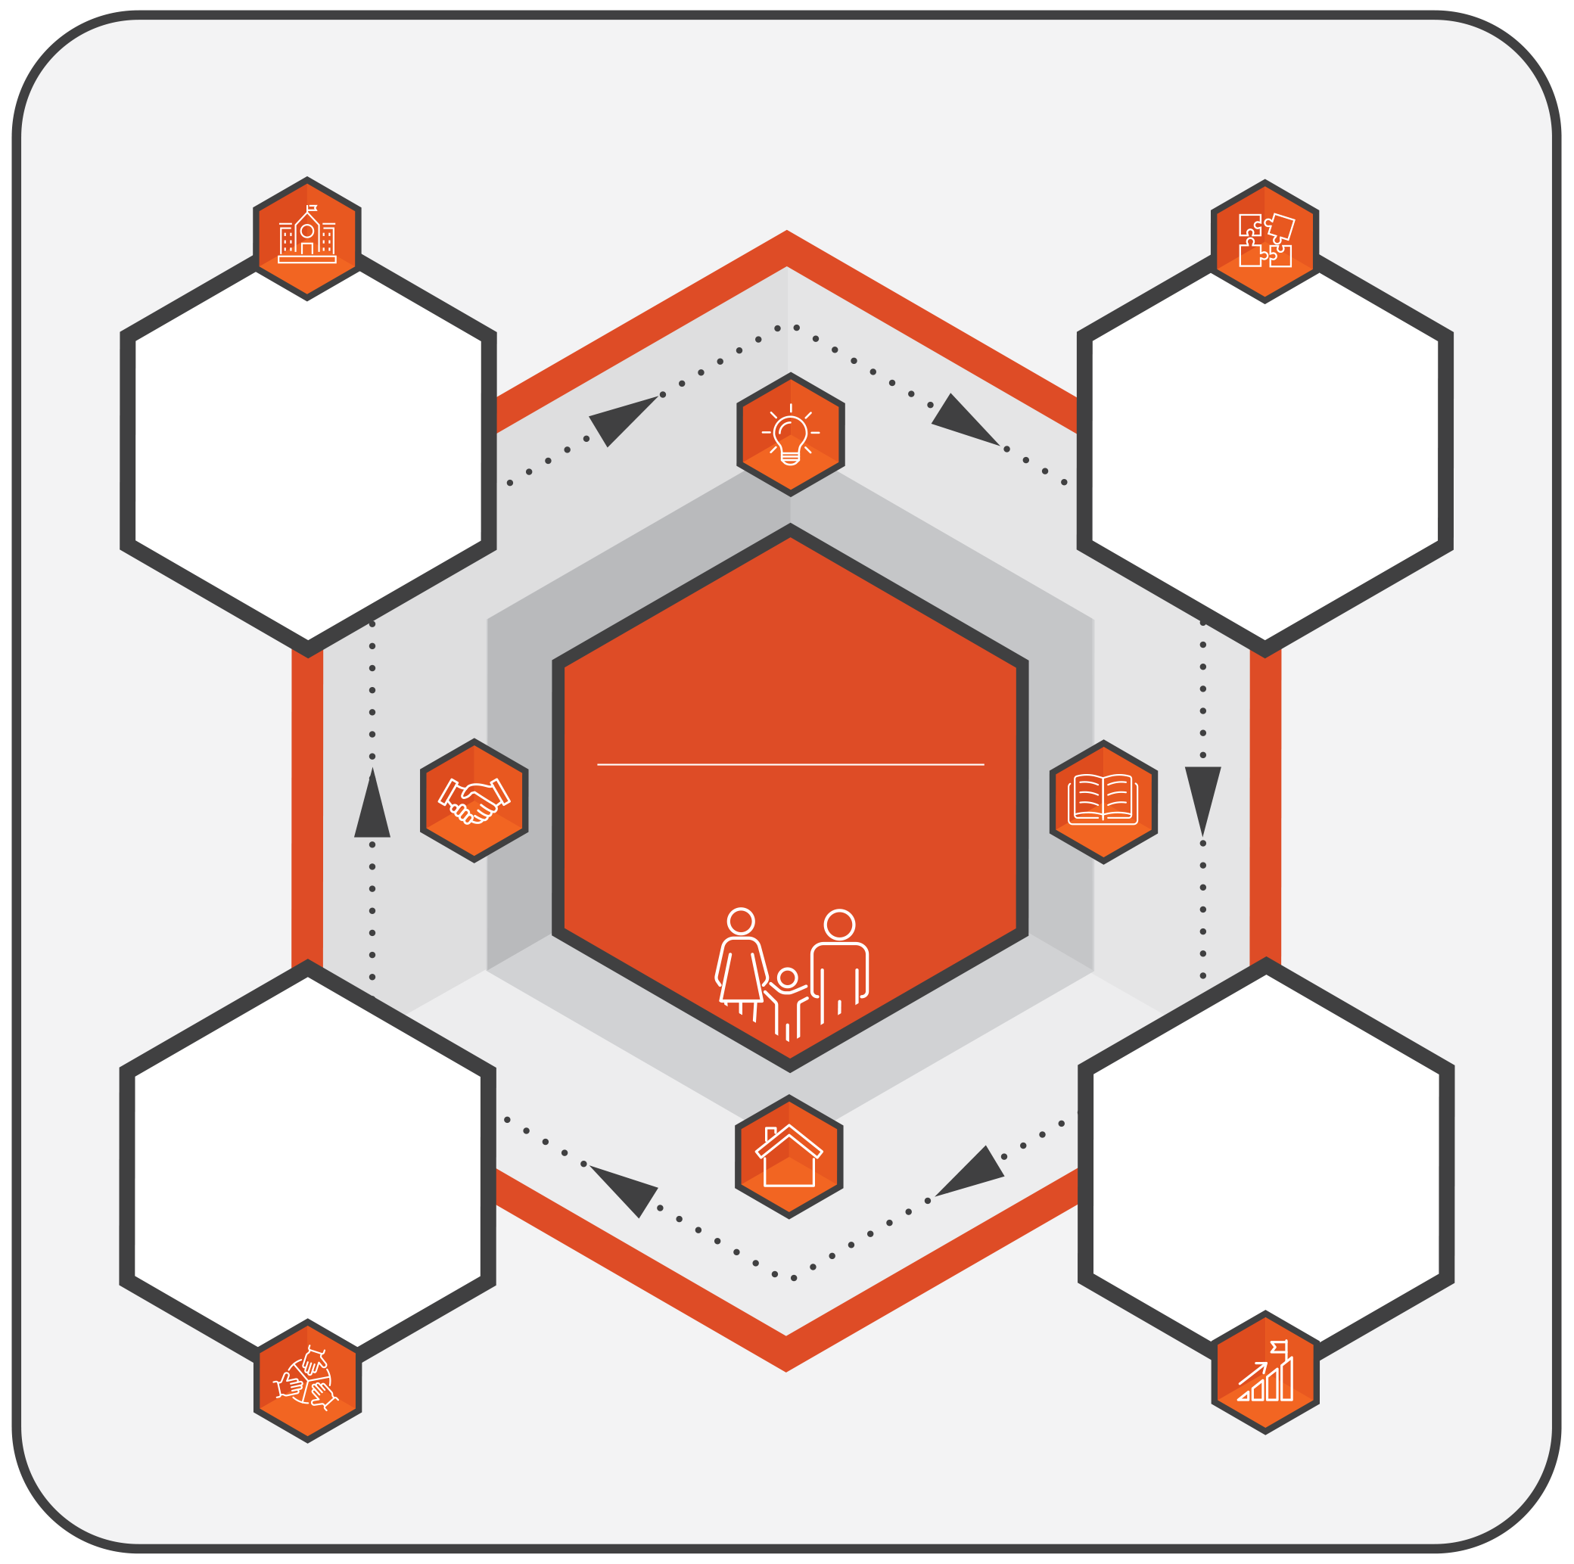
LFSA
LEARNERS AND FAMILIES SHAPING ACTION
EXPLORE CURRENT PRACTICES
How do partnerships work now?
FROM REFLECTION TO ACTION: STRENGTHENING PARTNERSHIPS
STRENGTHEN PARTNERSHIPS IN PRACTICE
Turning reflections into action
PLAN NEXT STEPS
What are realistic priorities for improvement?
IDENTIFY STRENGTHS AND GAPS
What works well and what needs strengthening?
Figure 3. Purpose of the tool


Learners’ level
This section supports learners in reflecting on their experiences of participation, belonging and voice in school and in the wider education system. It encourages discussion about how learners can share their ideas, raise concerns and take part in decisions that affect their learning and well-being, and how schools and authorities can create safe and inclusive spaces for this.
For example, a class, small group of learners or mixed group of learners and teachers may use this section to talk about how learners’ ideas are listened to in everyday school life, what helps them feel safe to speak and what could make participation easier for everyone. These conversations can help learners and adults better understand each other and agree on simple, practical improvements.
Learners may use this section in full or in part during classroom activities, group discussions or informal conversations, with questions adapted to different ages, communication styles and support needs.
Note: In this tool, ‘families’ refers to parents, caregivers or guardians who support learners and school life, and ‘community groups’ includes youth organisations, local services, non-governmental organisations and other groups that support learner participation or well-being.

Area 1: Knowing our rights and how school decisions are made


Goal 1.1: Learners know they have a right to be listened to and to take part in decisions about their education
Guiding question   | Prompt(s)  (Optional cues to guide reflection) | Current status  (Please rate performance on each area using the scale provided below) | Comments/evidence  (Examples from your experience that explain your answer)
1.1 Do you know that you have the right to share your ideas and be listened to when decisions are made about school life or learning? | Think of times you could share what you think in class, councils or meetings.  Think of whether adults explained what would happen next.  Think of how you learn about these rights (lessons, assemblies, posters) and whether all learners hear about them. | 0 = Not developed  1 = Initiated  2 = Developing  3 = Established

Goal 1.2: Schools explain clearly how learners can share ideas, give feedback or ask questions about school life
Guiding question | Prompt(s)  (Optional cues to guide reflection) | Current status  (Please rate performance on each area using the scale provided below) | Comments/evidence  (Examples from your experience that explain your answer)
1.2 Do you know where and how you can share ideas or questions about school life, at school or through community groups? | Think of who you can talk to when you have an idea or worry.  Think of how your school tells learners about channels and means (e.g. questionnaires, learner boards, discussions) through which they can share their ideas and questions.  Think of whether it feels safe and easy to share your views. | 0 = Not developed  1 = Initiated  2 = Developing  3 = Established

Area 2: Having a say in school life

Goal 2.1: Learners have regular chances to share ideas about school life and learning
Guiding question | Prompt(s)  (Optional cues to guide reflection) | Current status  (Please rate performance on each area using the scale provided below) | Comments/evidence  (Examples from your experience that explain your answer)
2.1 Do you get regular chances to share what you think about school life or learning and do you feel listened to? | Think of when you last shared your ideas in class or learner meetings.  Think of whether everyone gets a turn to speak, not only some learners.  Think of how adults make it feel safe to talk. | 0 = Not developed  1 = Initiated  2 = Developing  3 = Established

Goal 2.2: Learners see that their ideas are taken seriously and can lead to change
Guiding question | Prompt(s)  (Optional cues to guide reflection) | Current status  (Please rate performance on each area using the scale provided below) | Comments/evidence  (Examples from your experience that explain your answer)
2.2 Does the school tell learners what happens after ideas or feedback are shared? | Think of times when learners’ ideas helped change something at school.  Think of how you found out about the result (message, meeting, noticeboard).  Think of how it felt when your ideas made a difference. | 0 = Not developed  1 = Initiated  2 = Developing  3 = Established

Area 3: Feeling supported to take part

Goal 3.1: All learners have fair chances to join activities, councils or discussions that shape school life
Guiding question | Prompt(s)  (Optional cues to guide reflection) | Current status  (Please rate performance on each area using the scale provided below) | Comments/evidence  (Examples from your experience that explain your answer)
3.1 Do all learners have fair chances to join activities or meetings where they can share ideas about school life? | Think of who usually gets invited or chosen for councils or projects.  Think of whether different groups of learners (for example, based on language, background, disability, location) get the same chances.  Think of times when someone helped make it easier for everyone to join in. | 0 = Not developed  1 = Initiated  2 = Developing  3 = Established

Goal 3.2: Schools help learners build the skills and confidence to share ideas respectfully and clearly
Guiding question | Prompt(s)  (Optional cues to guide reflection) | Current status  (Please rate performance on each area using the scale provided below) | Comments/evidence  (Examples from your experience that explain your answer)
3.2 Does the school help learners practise how to share ideas and listen to others with respect? | Think of lessons or activities where learners learn to talk, listen or lead together.  Think of how adults encourage quieter voices to join in.  Think of whether practising these skills helps you feel more confident to speak in class or meetings. | 0 = Not developed  1 = Initiated  2 = Developing  3 = Established

Area 4: Sharing feedback and seeing change

Goal 4.1: Learners can give honest feedback about their learning and school experiences
Guiding question | Prompt(s)  (Optional cues to guide reflection) | Current status  (Please rate performance on each area using the scale provided below) | Comments/evidence  (Examples from your experience that explain your answer)
4.1 Do learners get chances to share honest feedback about classes, rules or school life? | Think of whether you have been asked what was going well or what could improve.  Think of whether it felt safe to speak honestly.  Think of examples where learner feedback was listened to carefully. | 0 = Not developed  1 = Initiated  2 = Developing  3 = Established

Goal 4.2: Schools let learners know what changed because of their feedback
Guiding question | Prompt(s)  (Optional cues to guide reflection) | Current status  (Please rate performance on each area using the scale provided below) | Comments/evidence  (Examples from your experience that explain your answer)
4.2 Does the school tell learners what has changed after they shared feedback or ideas? | Think of examples where learners’ ideas helped change something in class or around school.  Think of how you found out about the change (message, meeting, noticeboard).  Think of how it feels when your ideas make a difference. | 0 = Not developed  1 = Initiated  2 = Developing  3 = Established

Area 5: Learning together

Goal 5.1: Learners take part in activities that build teamwork, empathy and shared learning
Guiding question | Prompt(s)  (Optional cues to guide reflection) | Current status  (Please rate performance on each area using the scale provided below) | Comments/evidence  (Examples from your experience that explain your answer)
5.1 Do learners take part in activities that help them learn together and understand each other’s experiences? | Think of group projects, events or discussions where you learned from one another.  Think of how teamwork or empathy were encouraged.  Think of how learning together helped you see different points of view. | 0 = Not developed  1 = Initiated  2 = Developing  3 = Established

Goal 5.2: Learners and adults learn from one another about how to make learning more inclusive
Guiding question | Prompt(s)  (Optional cues to guide reflection) | Current status  (Please rate performance on each area using the scale provided below) | Comments/evidence  (Examples from your experience that explain your answer)
5.2 Do learners, the school, families or community groups share ideas with each other about how to make learning fair and welcoming for everyone? | Think of times when learner ideas improved lessons or activities.  Think of how adults listen to learner suggestions about inclusion or fairness.  Think of whether everyone’s ideas are valued and used. | 0 = Not developed  1 = Initiated  2 = Developing  3 = Established

Area 6: Belonging, care and working together

Goal 6.1: Learners feel they belong at school and can ask for help when they need it
Guiding question | Prompt(s)  (Optional cues to guide reflection) | Current status  (Please rate performance on each area using the scale provided below) | Comments/evidence  (Examples from your experience that explain your answer)
6.1 Do you feel welcome, included and able to ask for help when you need it at school? | Think of how people show care and respect (greetings, listening, helping).  Think of who you can go to if you feel left out or need support.  Think of examples where the school or a community group helped everyone feel they belong. | 0 = Not developed  1 = Initiated  2 = Developing  3 = Established

Goal 6.2: Learners take part in school or community actions that care for others and improve their shared environment
Guiding question | Prompt(s)  (Optional cues to guide reflection) | Current status  (Please rate performance on each area using the scale provided below) | Comments/evidence  (Examples from your experience that explain your answer)
6.2 Do learners take part in actions that help others or care for the school and community? | Think of projects where learners helped others, supported the environment or worked for a good cause.  Think of how these actions made people feel cared for or connected.  Think of what helps you and your classmates stay involved. | 0 = Not developed  1 = Initiated  2 = Developing  3 = Established

