Self-Reflection Tool on Partnerships in Education
Families
European Agency for Special Needs and Inclusive Education

The European Agency for Special Needs and Inclusive Education (EASNIE) is an independent and self-governing organisation. EASNIE is co-funded by the ministries of education in its member countries and by the European Commission via an operating grant within the European Union (EU) education programme.

Funded by the European Union. Views and opinions expressed are however those of the author(s) only and do not necessarily reflect those of the European Union or the European Commission. Neither the European Union nor the European Commission can be held responsible for them.

The views expressed by any individual in this document do not necessarily represent the official views of EASNIE, its member countries or the European Commission.
© European Agency for Special Needs and Inclusive Education 2025
Editors: Pamela Zoe Topalli, Antonella Mangiaracina and Katherina Alvarez
This publication is an open-source resource. This means you are free to access, use, modify and disseminate it with appropriate credit to the European Agency for Special Needs and Inclusive Education. Please refer to EASNIE’s Open Access Policy for more information: www.european-agency.org/open-access-policy.
You may cite this publication as follows: European Agency for Special Needs and Inclusive Education, 2025. Self-Reflection Tool on Partnerships in Education: Families. (P. Z. Topalli, A. Mangiaracina and K. Alvarez, eds.). Odense, Denmark


This work is licensed under a Creative Commons Attribution-NonCommercial-ShareAlike 4.0 International License.
You are free to share and adapt this publication.
With a view to greater accessibility, this report is available in accessible electronic format on EASNIE’s website: www.european-agency.org

Secretariat
Østre Stationsvej 33
DK-5000 Odense C Denmark
Tel.: +45 64 41 00 20
secretariat@european-agency.org
Brussels Office
Rue Montoyer 21
BE-1000 Brussels Belgium
Tel.: +32 2 213 62 80
brussels.office@european-agency.org

Contents
Self-reflection tool on partnerships in education 4
Purpose 4
How the tool is organised 5
Using the tool 7
Using the developmental scale 7
Reflection process 7
Key principles 7
Families’ level 9
Area 1: Awareness of rights, policies and shared commitments 10
Goal 1.1: Families are aware of their rights and opportunities to participate in learners’ education 10
Goal 1.2: Families receive information about partnership and participation in clear, accessible formats 11
Area 2: Participation and shared decision-making 12
Goal 2.1: Families have meaningful opportunities to express their views and influence school decisions that affect learners 12
Goal 2.2: Schools and families make decisions together in ways that respect each other’s knowledge and experience 14
Area 3: Support and resources for family participation 15
Goal 3.1: Schools and communities provide accessible opportunities (time, space, materials) for families to engage 15
Goal 3.2: Families know where to go for information or support about learners’ learning or inclusion 16
Area 4: Feedback, communication and responsiveness 17
Goal 4.1: Families can share feedback about their experiences with schools and notice that it leads to change 17
Goal 4.2: Families receive updates about how their input has been used or responded to 18
Area 5: Learning together 19
Goal 5.1: Families are supported to understand how they can contribute to learners’ learning and well-being 19
Goal 5.2: Families and school staff learn from one another through on-going dialogue 20
Area 6: Trust, belonging and community collaboration 21
Goal 6.1: Families feel welcomed, respected and safe to raise concerns or share ideas 21
Goal 6.2: Families collaborate with schools and community groups to support learners’
well-being and inclusion 22

Self-reflection tool on partnerships in education

Purpose
This self-reflection tool helps decision-makers, schools, communities, families and learners explore how partnerships currently work in practice and how to strengthen them. It supports users to recognise strengths, identify gaps and plan realistic next steps across six partnership areas.
It is an output from the Learners and Families Shaping Action (LFSA) activity, conducted by the European Agency for Special Needs and Inclusive Education (EASNIE).
The tool has five sections, one for each group of partners. While sections are organised by partner group, the tool should be used collaboratively wherever possible, with different perspectives informing reflection on the same areas. All five sections and the accompanying Guidance and Methodology Report are available on:
www.european-agency.org/resources/publications/LFSA-tool.
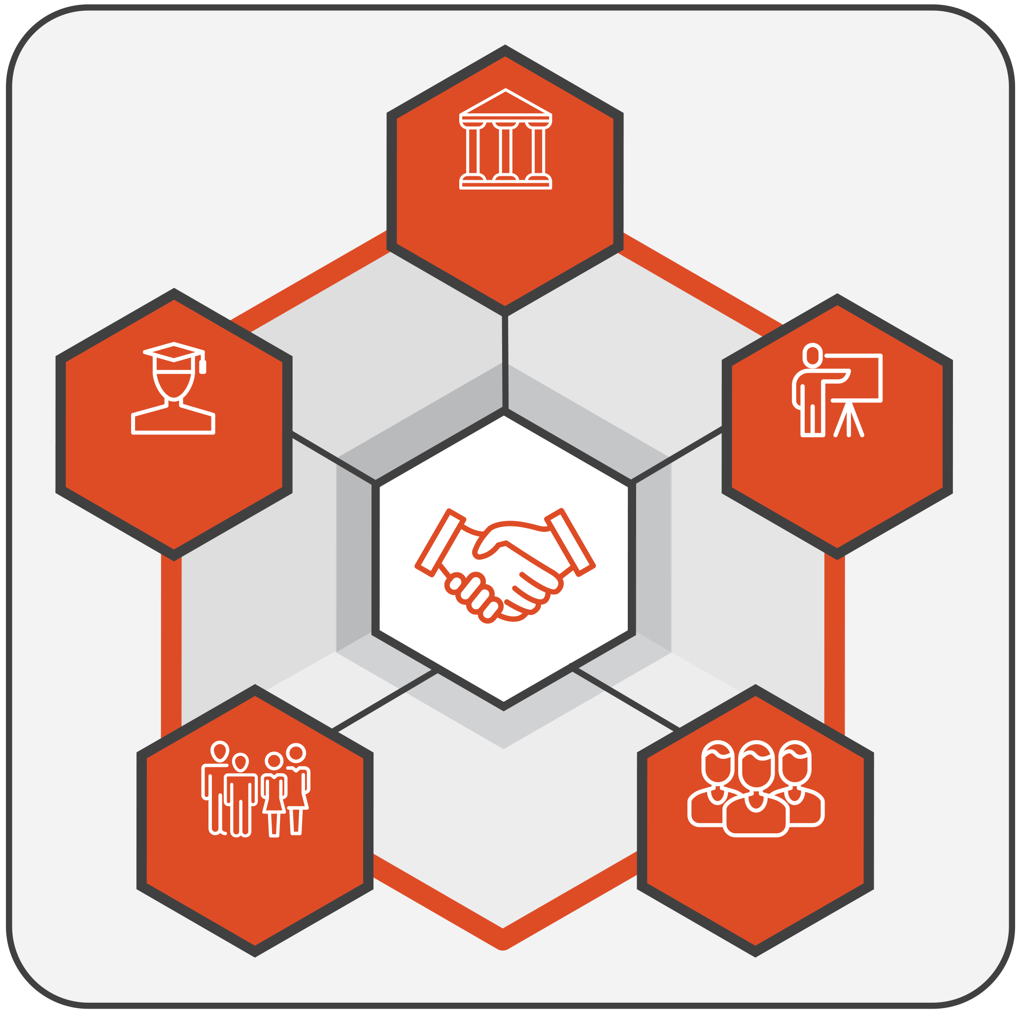
DECISION-MAKERS
LEARNERS
FAMILIES
SCHOOLS
COMMUNITIES
Figure 1. Partners

How the tool is organised
The tool has a dedicated section for each specific group of partners (decision-makers, schools, community, families, learners). Each section has the following structure:
- Area: The broad domain or theme for reflection (for example, legislation, governance, resources).
- Goal: The specific aim or expected outcome for that area.
- Guiding questions: Focused questions designed to prompt reflection and dialogue.
- Prompt(s): Optional cues that help you think more concretely about the question (for example, ‘Are there feedback channels to families?’, ‘Is learner input reflected in policy?’). Prompts aim to help guide deeper discussion.
- Current status: A four-point developmental scale showing where practice currently stands:
  - 0 = Not developed: No structures or processes in place.
  - 1 = Initiated: Early steps that often depend on individual commitment, short-term projects or specific contexts, and are not yet embedded in formal structures, procedures or resourcing.
  - 2 = Developing: Practices are becoming more coherent, responsibilities are clearer and less dependent on individual actors, and implementation is expanding across contexts. However, consistency, sustainability or system-wide reach are not yet fully ensured.
  - 3 = Established: Partnership is fully integrated, regularly reviewed and used to inform improvement.
- Comments/evidence: Short notes or examples supporting your reflection (for example, reference to a national policy, school strategy, meeting record or evaluation report). These can include both policy evidence (frameworks, regulations or formal commitments) and practice evidence (documents, actions or data showing implementation). Where relevant, you may wish to mention the source or context briefly to help track progress over time.
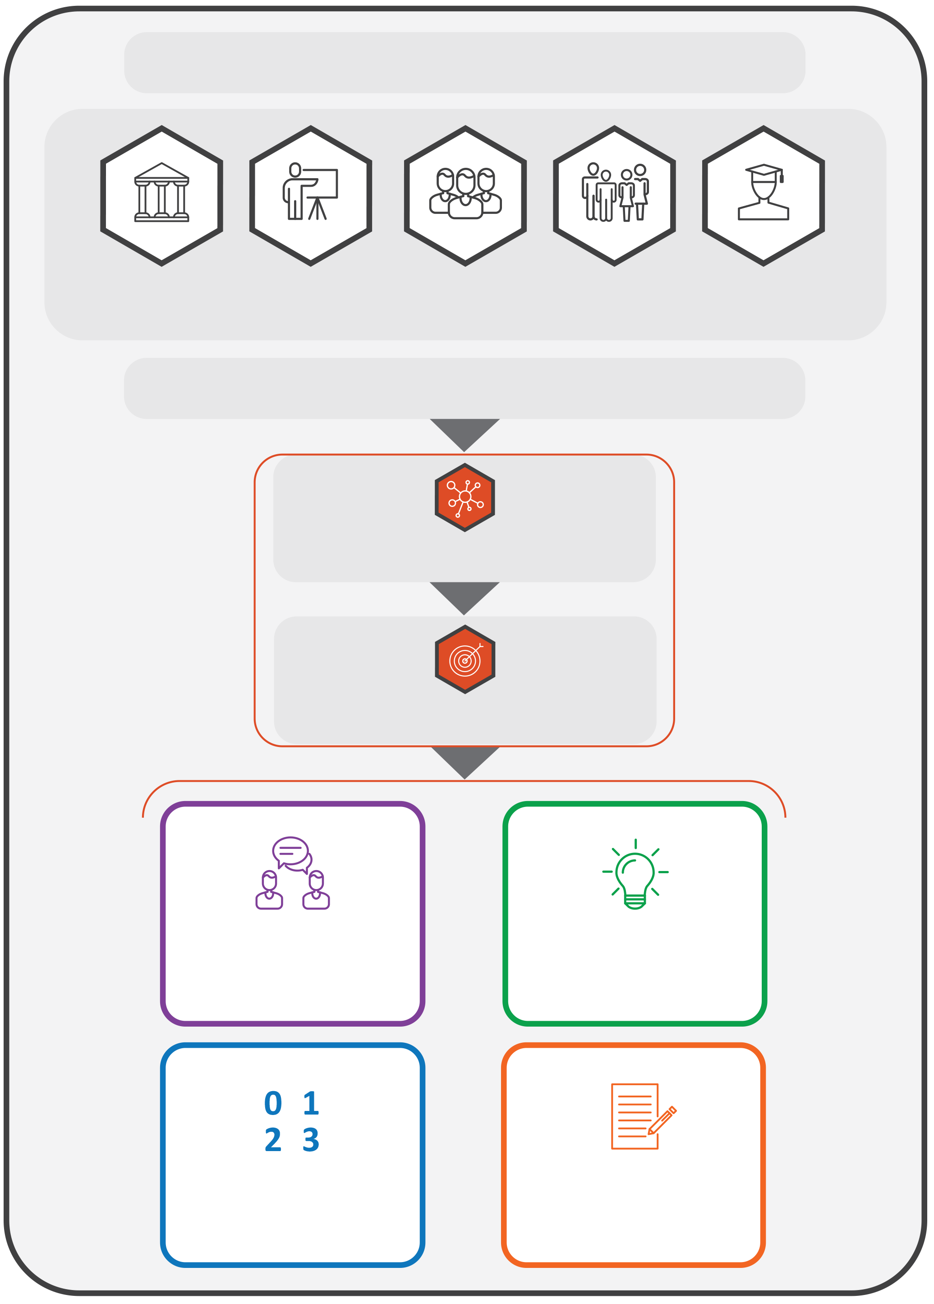
THE TOOL HAS A SECTION FOR EACH GROUP OF PARTNERS

DECISION-MAKERS
LEARNERS
FAMILIES
SCHOOLS
COMMUNITIES
EACH SECTION IS STRUCTURED AS FOLLOWS:
AREA
GOAL
GUIDING QUESTIONS
CURRENT STATUS
PROMPTS
COMMENTS/ EVIDENCE
Figure 2. Structure of the tool

Using the tool
The tool can be used to:
- support internal reflection within ministries, departments and schools;
- structure dialogue between decision-makers and partners;
- inform policy review, strategy development or funding design;
- complement existing monitoring, evaluation or peer-learning processes.

Using the developmental scale
The 0–3 scale is not for comparison or ranking. It helps users to consider where they are now and to identify realistic next steps for growth. It shows how well partnership is included in everyday practice, rather than treated as a one-off activity.

Reflection process
- Review each area and the guiding questions.
- Discuss and agree on a rating (0–3) based on the available information.
- Enter short examples or notes in the ‘Comments/evidence’ column.
- Identify two or three concrete next steps for improvement.
- Revisit periodically (for example, once a year) to monitor change and share learning.
You may choose to reflect on all six areas or focus on those most relevant to your current priorities. The tool is designed to be flexible: you may adapt the sections, questions or language to fit your context and capacity.

Key principles
- Developmental, not evaluative: The tool supports learning and improvement, not inspection.
- Collaborative: Reflection should, whenever possible, bring together multiple perspectives.
- Inclusive: All partners (decision-makers, schools, communities, families and learners) contribute to partnership quality.
- Flexible: The tool can be used in full or in part, depending on purpose and timing. Countries, regions or institutions may combine or simplify questions, focus on selected areas or adapt the format to align with national processes and capacity. It can serve as a stand-alone reflection activity, part of a peer-learning exchange or input for national reviews.
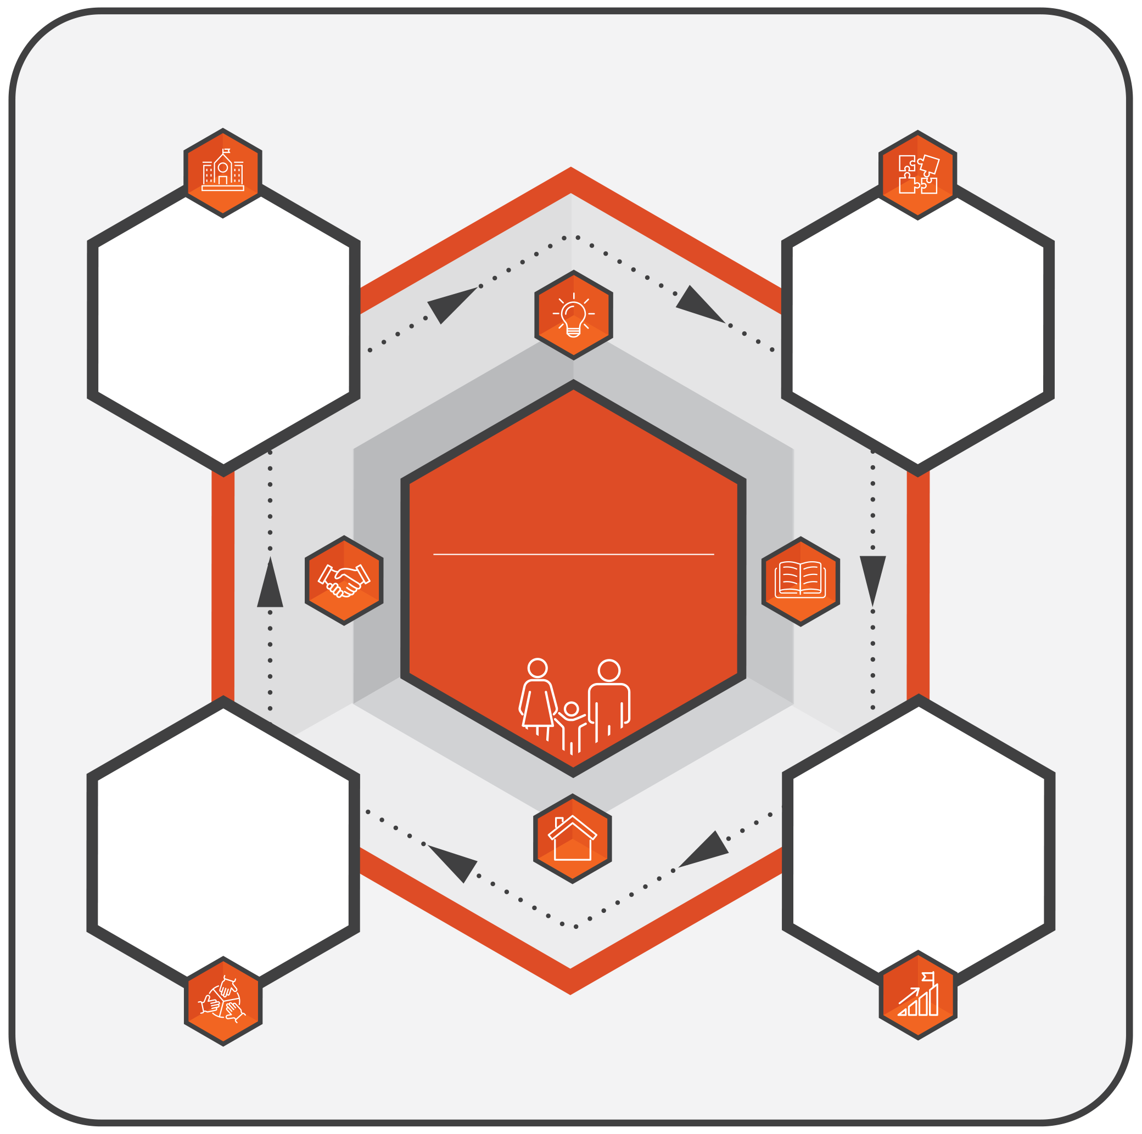
LFSA
LEARNERS AND FAMILIES SHAPING ACTION
EXPLORE CURRENT PRACTICES
How do partnerships work now?
FROM REFLECTION TO ACTION: STRENGTHENING PARTNERSHIPS
STRENGTHEN PARTNERSHIPS IN PRACTICE
Turning reflections into action
PLAN NEXT STEPS
What are realistic priorities for improvement?
IDENTIFY STRENGTHS AND GAPS
What works well and what needs strengthening?
Figure 3. Purpose of the tool


Families’ level
This section supports families, parents, caregivers and guardians in reflecting on how they participate in and influence school life and education decisions. It focuses on communication, participation and trust between families, schools and education authorities, helping to identify both strengths and barriers.
Families can use this section, in full or in part, individually, in parent associations or as part of broader dialogues, adapting questions to what they consider most relevant and accessible.
Note: In this tool, ‘families’ includes all parents, caregivers and guardians who support learners, and ‘community groups’ includes parent associations, non-governmental organisations, councils and local service networks.

Area 1: Awareness of rights, policies and shared commitments


Goal 1.1: Families are aware of their rights and opportunities to participate in learners’ education
Guiding question   | Prompt(s)  (Optional cues to guide reflection) | Current status  (Please rate performance on each area using the scale provided below) | Comments/evidence  (Brief examples or references that support your answer, e.g. national policy text, law, strategy, consultation minutes, monitoring report)
1.1a Do schools and community groups make it easy for families to find clear information about their own and learners’ rights to participate in school decisions? | Think of where families usually get information about their rights or participation (for example, school meetings, newsletters, parent associations, ministry or municipal websites).  Think of whether families discuss these rights with learners at home or in their community.  Think of examples where knowing this information helped families speak up or join in a decision. | 0 = Not developed  1 = Initiated  2 = Developing  3 = Established

Goal 1.2: Families receive information about partnership and participation in clear, accessible formats
Guiding question | Prompt(s)  (Optional cues to guide reflection) | Current status  (Please rate performance on each area using the scale provided below) | Comments/evidence  (Brief examples or references that support your answer, e.g. national policy text, law, strategy, consultation minutes, monitoring report)
1.2a Do schools and community groups share information about partnership and participation in ways that all families can understand and use? | Think of how schools or community groups share information (for example, meetings, WhatsApp, letters, visual displays).  Think of whether information is available in families’ preferred languages or accessible formats.  Think of examples where clear or translated communication made it easier for families to participate. | 0 = Not developed  1 = Initiated  2 = Developing  3 = Established
1.2b Do you have opportunities to ask questions or share feedback with schools or community groups when information is confusing or does not tell you what you need to know? | Think of times when families could ask for clarification (for example, at meetings, through teachers or via community representatives).  Think of how schools or community groups respond when families ask for more information.  Think of whether families feel comfortable and supported when raising these questions. | 0 = Not developed  1 = Initiated  2 = Developing  3 = Established

Area 2: Participation and shared decision-making

Goal 2.1: Families have meaningful opportunities to express their views and influence school decisions that affect learners
Guiding question | Prompt(s)  (Optional cues to guide reflection) | Current status  (Please rate performance on each area using the scale provided below) | Comments/evidence  (Brief examples or references that support your answer, e.g. national policy text, law, strategy, consultation minutes, monitoring report)
2.1a Do you have regular, safe opportunities to share your views about school life and learning? | Think of where families can share opinions or suggestions (for example, meetings, surveys, informal talks, parent groups).  Think of whether all families, including those who are often less heard, can participate.  Think of examples where families’ views were discussed and led to action.  Think of whether there are multiple ways to participate (in-person, online, written) so more families can join in. | 0 = Not developed  1 = Initiated  2 = Developing  3 = Established
2.1b Do schools and communities communicate what happens after families share their ideas or feedback? | Think of how schools or community groups communicate what happens after families share ideas (for example, newsletters, class updates, meetings).  Think of examples where families saw that their suggestions or concerns were taken seriously.  Think of whether communication feels open and respectful, even when decisions differ. | 0 = Not developed  1 = Initiated  2 = Developing  3 = Established

Goal 2.2: Schools and families make decisions together in ways that respect each other’s knowledge and experience
Guiding question | Prompt(s)  (Optional cues to guide reflection) | Current status  (Please rate performance on each area using the scale provided below) | Comments/evidence  (Brief examples or references that support your answer, e.g. national policy text, law, strategy, consultation minutes, monitoring report)
2.2a Do families and schools (sometimes together with community groups) discuss and decide together on matters related to learning, support or school priorities? | Think of how families are invited to joint planning or review meetings.  Think of examples where decisions were shaped together with teachers or school leaders.  Think of whether family experience and knowledge of learners’ needs are valued.  Think of how families show respect for teachers’ professional knowledge and expertise during these discussions. | 0 = Not developed  1 = Initiated  2 = Developing  3 = Established
2.2b Do you feel that decision-making processes are transparent and that everyone understands how final decisions are reached? | Think of how schools explain the steps or reasons behind decisions that affect learners or families.  Think of examples where clear information helped avoid confusion or build trust.  Think of whether families feel informed and respected, even when outcomes differ from their views. | 0 = Not developed  1 = Initiated  2 = Developing  3 = Established

Area 3: Support and resources for family participation

Goal 3.1: Schools and communities provide accessible opportunities (time, space, materials) for families to engage
Guiding question | Prompt(s)  (Optional cues to guide reflection) | Current status  (Please rate performance on each area using the scale provided below) | Comments/evidence  (Brief examples or references that support your answer, e.g. national policy text, law, strategy, consultation minutes, monitoring report)
3.1a Do schools and community groups offer meeting times, spaces or activities that make it easy for different families to participate? | Think of when and where family activities usually take place (for example, after work hours, online options, child-friendly spaces).  Think of whether these arrangements work for most families or only some.  Think of examples where a change in timing or venue helped more people join. | 0 = Not developed  1 = Initiated  2 = Developing  3 = Established
3.1b Do schools and community groups provide the practical supports families need to participate meaningfully (for example, translation, childcare or transport)? | Think of which practical supports help families attend or share ideas.  Think of examples where these supports made participation easier or more inclusive.  Think of whether schools ask families what kind of support would help most. | 0 = Not developed  1 = Initiated  2 = Developing  3 = Established

Goal 3.2: Families know where to go for information or support about learners’ learning or inclusion
Guiding question | Prompt(s)  (Optional cues to guide reflection) | Current status  (Please rate performance on each area using the scale provided below) | Comments/evidence  (Brief examples or references that support your answer, e.g. national policy text, law, strategy, consultation minutes, monitoring report)
3.2a Do you know who to contact when you have questions or need help about learners’ learning or well-being? | Think of how families usually contact the school or community for information or support.  Think of whether families receive timely and helpful responses.  Think of examples where clear contact points helped solve a problem or reduce stress. | 0 = Not developed  1 = Initiated  2 = Developing  3 = Established
3.2b Do schools and community groups keep families informed about available supports or services (for example, counselling, tutoring or social assistance)? | Think of how information about supports is shared (for example, leaflets, websites, group messages).  Think of whether these updates are regular and easy to understand.  Think of examples where this information helped families access extra help when needed. | 0 = Not developed  1 = Initiated  2 = Developing  3 = Established

Area 4: Feedback, communication and responsiveness

Goal 4.1: Families can share feedback about their experiences with schools and notice that it leads to change
Guiding question | Prompt(s)  (Optional cues to guide reflection) | Current status  (Please rate performance on each area using the scale provided below) | Comments/evidence  (Brief examples or references that support your answer, e.g. national policy text, law, strategy, consultation minutes, monitoring report)
4.1a Do schools and communities provide regular and safe ways for families to share feedback about their experiences with learning, communication or partnership? | Think of how families can share their views (for example, surveys, meetings, suggestion boxes, parent groups).  Think of whether families receive respectful responses to concerns or ideas.  Think of examples where family feedback led to a positive change in school or community practice. | 0 = Not developed  1 = Initiated  2 = Developing  3 = Established
4.1b Do schools and communities work together to review and discuss family feedback and identify actions for improvement? | Think of how feedback results are discussed (for example, review meetings, parent–teacher forums).  Think of examples where families and staff agreed on next steps after reviewing feedback.  Think of whether families are invited to help shape solutions, not only identify problems. | 0 = Not developed  1 = Initiated  2 = Developing  3 = Established

Goal 4.2: Families receive updates about how their input has been used or responded to
Guiding question | Prompt(s)  (Optional cues to guide reflection) | Current status  (Please rate performance on each area using the scale provided below) | Comments/evidence  (Brief examples or references that support your answer, e.g. national policy text, law, strategy, consultation minutes, monitoring report)
4.2a Do schools and community groups communicate to families about actions taken after feedback? | Think of how families are informed about follow-up actions (for example, newsletters, emails, meetings).  Think of examples where families saw how their ideas or concerns led to improvements.  Think of whether this feedback loop happens regularly and reaches all families. | 0 = Not developed  1 = Initiated  2 = Developing  3 = Established
4.2b Do you have ways to respond or add further suggestions after schools or communities share updates? | Think of whether schools or communities invite follow-up comments or questions after changes are made.  Think of examples where families’ continued dialogue improved understanding or outcomes.  Think of whether communication feels two-way, not one-sided. | 0 = Not developed  1 = Initiated  2 = Developing  3 = Established

Area 5: Learning together

Goal 5.1: Families are supported to understand how they can contribute to learners’ learning and well-being
Guiding question | Prompt(s)  (Optional cues to guide reflection) | Current status  (Please rate performance on each area using the scale provided below) | Comments/evidence  (Brief examples or references that support your answer, e.g. national policy text, law, strategy, consultation minutes, monitoring report)
5.1a Do schools and community groups offer families clear information or activities that help them support learners’ learning and well-being at home and at school? | Think of what helps families understand how to support learning (for example, meetings, guides, online sessions).  Think of examples where these activities helped families feel more confident or connected with teachers.  Think of whether these supports are accessible for families with different languages, schedules or needs. | 0 = Not developed  1 = Initiated  2 = Developing  3 = Established
5.1b Do you have opportunities to share your own experiences or strategies that support learners’ learning and well-being? | Think of examples where families shared ideas that teachers or other families found helpful.  Think of how schools or community groups create space for this exchange (for example, parent groups, workshops).  Think of whether shared learning is valued and used to improve practice. | 0 = Not developed  1 = Initiated  2 = Developing  3 = Established

Goal 5.2: Families and school staff learn from one another through on-going dialogue
Guiding question | Prompt(s)  (Optional cues to guide reflection) | Current status  (Please rate performance on each area using the scale provided below) | Comments/evidence  (Brief examples or references that support your answer, e.g. national policy text, law, strategy, consultation minutes, monitoring report)
5.2a Do schools and families have regular opportunities to learn together about how to make education more inclusive and supportive for all learners? | Think of shared learning sessions or discussions (for example, about inclusion, communication or well-being).  Think of examples where joint learning led to new ideas or better co-operation.  Think of how families and staff share responsibility for putting these ideas into practice. | 0 = Not developed  1 = Initiated  2 = Developing  3 = Established
5.2b Do schools and families reflect together on what they are learning from their collaboration and how it can be improved? | Think of how families and staff review progress together (for example, end-of-year reflections, parent–teacher forums).  Think of examples where reflection helped strengthen mutual understanding or future planning.  Think of whether both sides feel heard and respected in these conversations. | 0 = Not developed  1 = Initiated  2 = Developing  3 = Established

Area 6: Trust, belonging and community collaboration

Goal 6.1: Families feel welcomed, respected and safe to raise concerns or share ideas
Guiding question | Prompt(s)  (Optional cues to guide reflection) | Current status  (Please rate performance on each area using the scale provided below) | Comments/evidence  (Brief examples or references that support your answer, e.g. national policy text, law, strategy, consultation minutes, monitoring report)
6.1a Do you feel welcomed and respected in the school community, regardless of background, language or circumstance? | Think of how schools and communities show care and respect (for example, greetings, communication tone, inclusion in activities, welcoming cultural brokers, family advocates).  Think of whether families feel safe to approach teachers or leaders with ideas or concerns.  Think of examples where efforts to welcome all families strengthened trust or belonging. | 0 = Not developed  1 = Initiated  2 = Developing  3 = Established
6.1b Do you have safe, confidential ways to share concerns or suggestions, with clear follow-up from schools or community groups? | Think of what channels exist for families to raise issues (for example, private meetings, surveys, family liaisons).  Think of examples where families’ concerns were addressed respectfully and led to improvements.  Think of whether families are informed about the steps taken in response to their input. | 0 = Not developed  1 = Initiated  2 = Developing  3 = Established

Goal 6.2: Families collaborate with schools and community groups to support learners’ well-being and inclusion
Guiding question | Prompt(s)  (Optional cues to guide reflection) | Current status  (Please rate performance on each area using the scale provided below) | Comments/evidence  (Brief examples or references that support your answer, e.g. national policy text, law, strategy, consultation minutes, monitoring report)
6.2a Do families, schools and community groups work together to support learners’ well-being and participation in school life? | Think of examples where families, teachers and community groups worked together to help a learner or group of learners.  Think of how roles and responsibilities were shared and respected.  Think of whether this co-operation helped learners feel more included and supported. | 0 = Not developed  1 = Initiated  2 = Developing  3 = Established
6.2b Do you participate in community or school initiatives that promote care, inclusion or connection among learners and families? | Think of activities or events that bring families together to build community (for example, cultural events, peer support, volunteering).  Think of examples where family participation helped strengthen relationships or belonging.  Think of how schools or communities recognise and appreciate these contributions. | 0 = Not developed  1 = Initiated  2 = Developing  3 = Established
6.2c Do you actively contribute to building respectful, supportive and constructive relationships with teachers and school staff? | Think of how families communicate concerns in ways that support dialogue and problem-solving.  Think of whether families encourage learners to value and respect teachers and school staff.  Think of how families show respect or recognition for teachers’ work. | 0 = Not developed  1 = Initiated  2 = Developing  3 = Established

