Self-Reflection Tool on Partnerships in Education
Decision-makers
European Agency for Special Needs and Inclusive Education

The European Agency for Special Needs and Inclusive Education (EASNIE) is an independent and self-governing organisation. EASNIE is co-funded by the ministries of education in its member countries and by the European Commission via an operating grant within the European Union (EU) education programme.

Funded by the European Union. Views and opinions expressed are however those of the author(s) only and do not necessarily reflect those of the European Union or the European Commission. Neither the European Union nor the European Commission can be held responsible for them.

The views expressed by any individual in this document do not necessarily represent the official views of EASNIE, its member countries or the European Commission.
© European Agency for Special Needs and Inclusive Education 2025
Editors: Pamela Zoe Topalli, Antonella Mangiaracina and Katherina Alvarez
This publication is an open-source resource. This means you are free to access, use, modify and disseminate it with appropriate credit to the European Agency for Special Needs and Inclusive Education. Please refer to EASNIE’s Open Access Policy for more information: www.european-agency.org/open-access-policy.
You may cite this publication as follows: European Agency for Special Needs and Inclusive Education, 2025. Self-Reflection Tool on Partnerships in Education: Decision-makers. (P. Z. Topalli, A. Mangiaracina and K. Alvarez, eds.). Odense, Denmark


This work is licensed under a Creative Commons Attribution-NonCommercial-ShareAlike 4.0 International License.
You are free to share and adapt this publication.
With a view to greater accessibility, this report is available in accessible electronic format on EASNIE’s website: www.european-agency.org

Secretariat
Østre Stationsvej 33
DK-5000 Odense C Denmark
Tel.: +45 64 41 00 20
secretariat@european-agency.org
Brussels Office
Rue Montoyer 21
BE-1000 Brussels Belgium
Tel.: +32 2 213 62 80
brussels.office@european-agency.org

Contents
Self-reflection tool on partnerships in education 4
Purpose 4
How the tool is organised 5
Using the tool 7
Using the developmental scale 7
Reflection process 7
Key principles 7
Decision-makers’ level 9
Area 1: Legislation and policy 9
Goal 1.1: Rights-based legislative and policy framework for partnerships (aligned with conventions) 9
Goal 1.2: Curriculum flexibility, accessibility, inclusive assessment and post-school
pathways 11
Goal 1.3: Participation of partners in national policy and curriculum development 12
Goal 1.4: Cross-ministerial coherence of partnership policies 14
Goal 1.5: Safeguards against exclusionary practices 15
Area 2: Governance 16
Goal 2.1: Clear governance roles and responsibilities for partnership engagement and decision-making 16
Goal 2.2: Mechanisms for partner representation and influence in governance structures 17
Goal 2.3: Co-ordination and capacity across governance levels for partnership 19
Area 3: Funding and resource allocation 20
Goal 3.1: Flexible funding mechanisms that enable partnership action 20
Goal 3.2: Clarity and accessibility of funding processes for partnerships 21
Goal 3.3: Equity-oriented and targeted funding to support partnerships and reach hard-to-reach groups 23
Area 4: Quality assurance, accountability and system data 24
Goal 4.1: Monitoring, reporting and accountability for partnership-related resource use 24
Goal 4.2: Ensuring that resources reach and benefit hard-to-reach groups 25
Goal 4.3: Collecting data on the sufficiency and quality of partner engagement 26
Goal 4.4: Evaluating the impact of partnership involvement on decision-making 27
Area 5: Capacity building and inclusive leadership 28
Goal 5.1: Embedding partnership in the vision for teacher professional learning (TPL) 28
Goal 5.2: Continuous professional development (CPD) for partnership competences 29
Goal 5.3: Leadership CPD to strengthen a culture of partnership 31
Goal 5.4: Building ministry and partner capacity for partnership 33
Area 6: Collaboration, communication and school-level co-operation 35
Goal 6.1: Intra- and inter-ministerial co-ordination for partnerships 35
Goal 6.2: On-going dialogue with schools, families, learners, communities and all education staff 36
Goal 6.3: Trusted channels for families, learners, schools and communities to raise concerns or feedback 37

Self-reflection tool on partnerships in education

Purpose
This self-reflection tool helps decision-makers, schools, communities, families and learners explore how partnerships currently work in practice and how to strengthen them. It supports users to recognise strengths, identify gaps and plan realistic next steps across six partnership areas.
It is an output from the Learners and Families Shaping Action (LFSA) activity, conducted by the European Agency for Special Needs and Inclusive Education (EASNIE).
The tool has five sections, one for each group of partners. While sections are organised by partner group, the tool should be used collaboratively wherever possible, with different perspectives informing reflection on the same areas. All five sections and the accompanying Guidance and Methodology Report are available on:
www.european-agency.org/resources/publications/LFSA-tool.
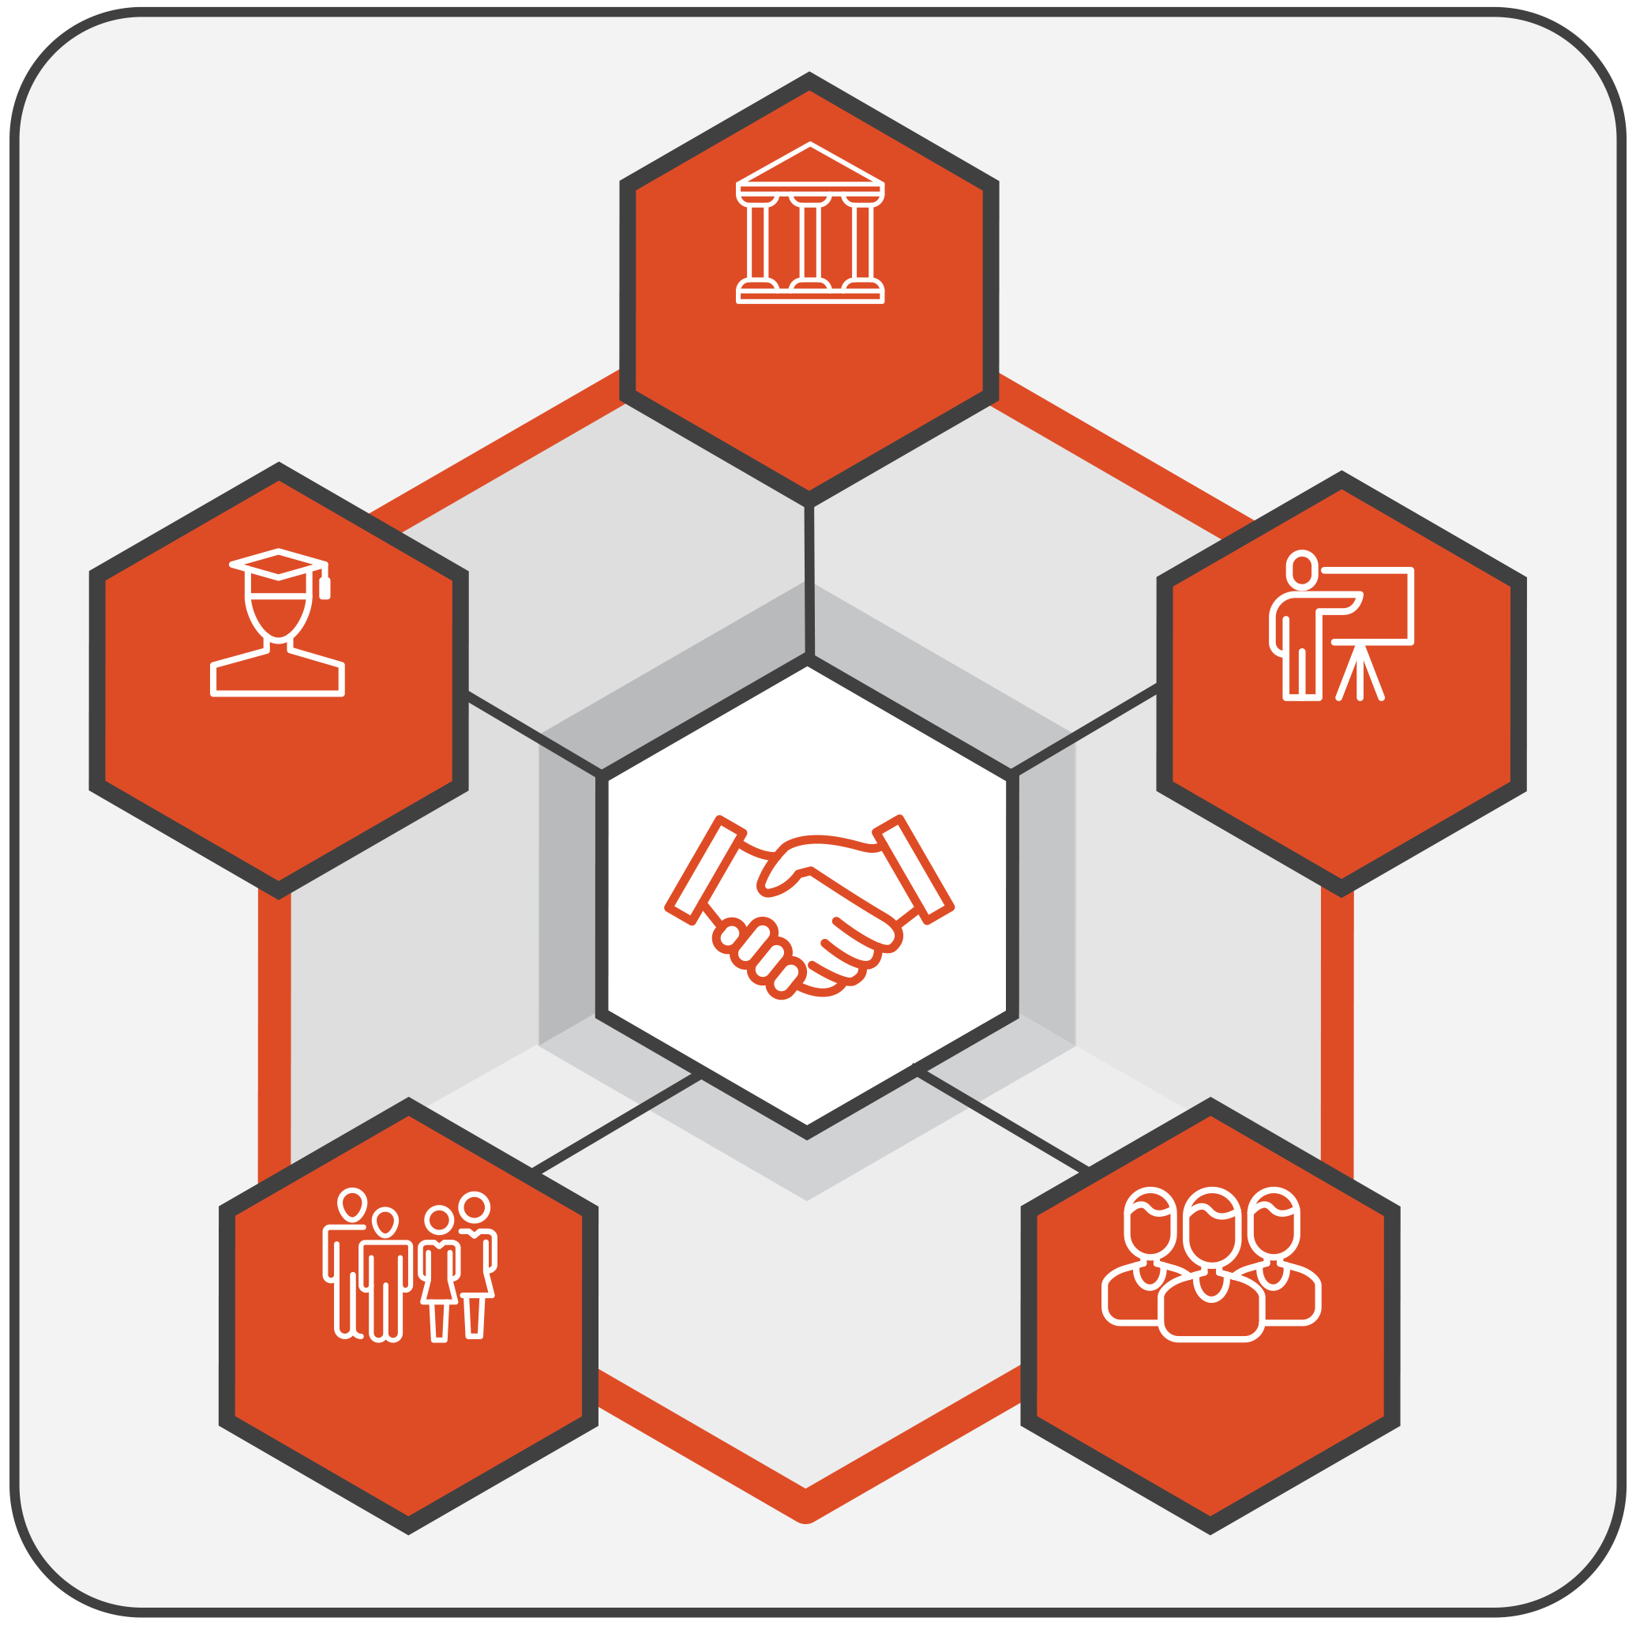
DECISION-MAKERS
LEARNERS
FAMILIES
SCHOOLS
COMMUNITIES
Figure 1. Partners

How the tool is organised
The tool has a dedicated section for each specific group of partners (decision-makers, schools, community, families, learners). Each section has the following structure:
- Area: The broad domain or theme for reflection (for example, legislation, governance, resources).
- Goal: The specific aim or expected outcome for that area.
- Guiding questions: Focused questions designed to prompt reflection and dialogue.
- Prompt(s): Optional cues that help you think more concretely about the question (for example, ‘Are there feedback channels to families?’, ‘Is learner input reflected in policy?’). Prompts aim to help guide deeper discussion.
- Current status: A four-point developmental scale showing where practice currently stands:
  - 0 = Not developed: No structures or processes in place.
  - 1 = Initiated: Early steps that often depend on individual commitment, short-term projects or specific contexts, and are not yet embedded in formal structures, procedures or resourcing.
  - 2 = Developing: Practices are becoming more coherent, responsibilities are clearer and less dependent on individual actors, and implementation is expanding across contexts. However, consistency, sustainability or system-wide reach are not yet fully ensured.
  - 3 = Established: Partnership is fully integrated, regularly reviewed and used to inform improvement.
- Comments/evidence: Short notes or examples supporting your reflection (for example, reference to a national policy, school strategy, meeting record or evaluation report). These can include both policy evidence (frameworks, regulations or formal commitments) and practice evidence (documents, actions or data showing implementation). Where relevant, you may wish to mention the source or context briefly to help track progress over time.
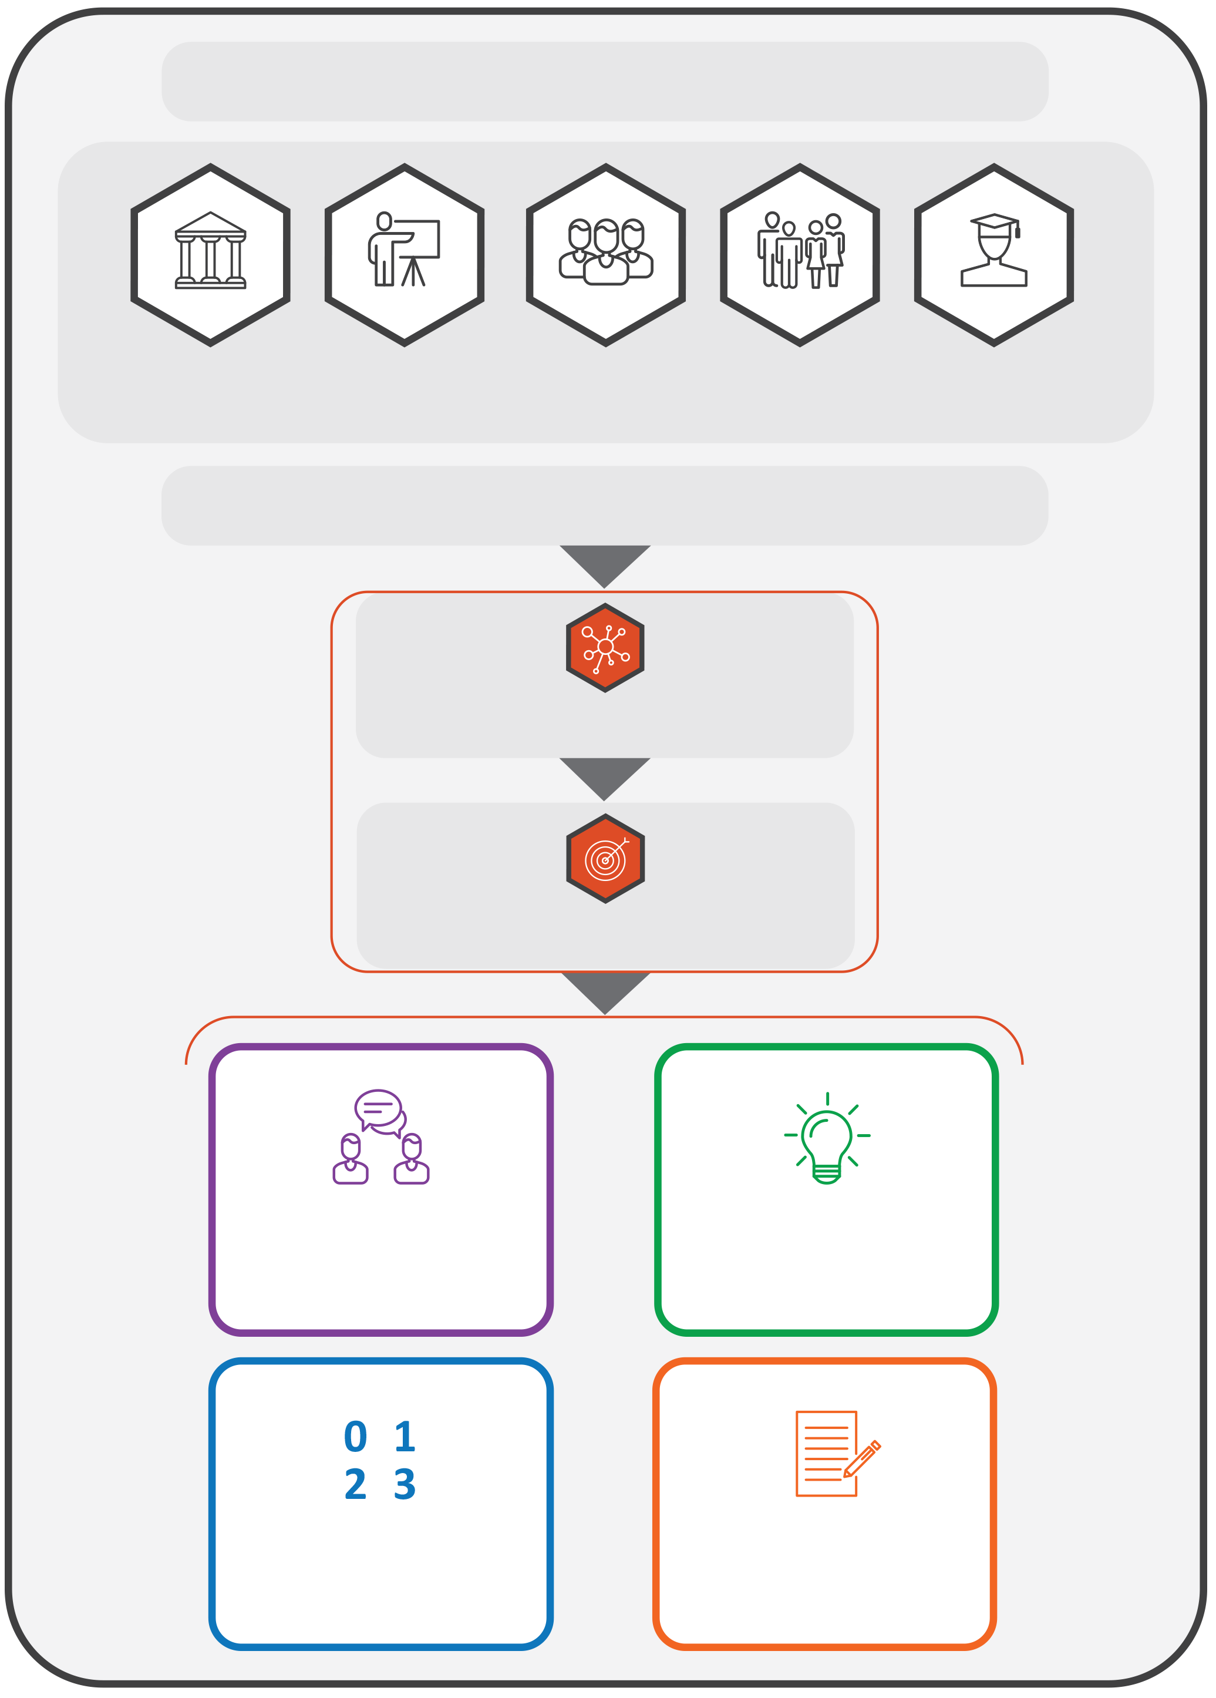
THE TOOL HAS A SECTION FOR EACH GROUP OF PARTNERS

DECISION-MAKERS
LEARNERS
FAMILIES
SCHOOLS
COMMUNITIES
EACH SECTION IS STRUCTURED AS FOLLOWS:
AREA
GOAL
GUIDING QUESTIONS
CURRENT STATUS
PROMPTS
COMMENTS/ EVIDENCE
Figure 2. Structure of the tool

Using the tool
The tool can be used to:
- support internal reflection within ministries, departments and schools;
- structure dialogue between decision-makers and partners;
- inform policy review, strategy development or funding design;
- complement existing monitoring, evaluation or peer-learning processes.

Using the developmental scale
The 0–3 scale is not for comparison or ranking. It helps users to consider where they are now and to identify realistic next steps for growth. It shows how well partnership is included in everyday practice, rather than treated as a one-off activity.

Reflection process
- Review each area and the guiding questions.
- Discuss and agree on a rating (0–3) based on the available information.
- Enter short examples or notes in the ‘Comments/evidence’ column.
- Identify two or three concrete next steps for improvement.
- Revisit periodically (for example, once a year) to monitor change and share learning.
You may choose to reflect on all six areas or focus on those most relevant to your current priorities. The tool is designed to be flexible: you may adapt the sections, questions or language to fit your context and capacity.

Key principles
- Developmental, not evaluative: The tool supports learning and improvement, not inspection.
- Collaborative: Reflection should, whenever possible, bring together multiple perspectives.
- Inclusive: All partners (decision-makers, schools, communities, families and learners) contribute to partnership quality.
- Flexible: The tool can be used in full or in part, depending on purpose and timing. Countries, regions or institutions may combine or simplify questions, focus on selected areas or adapt the format to align with national processes and capacity. It can serve as a stand-alone reflection activity, part of a peer-learning exchange or input for national reviews.
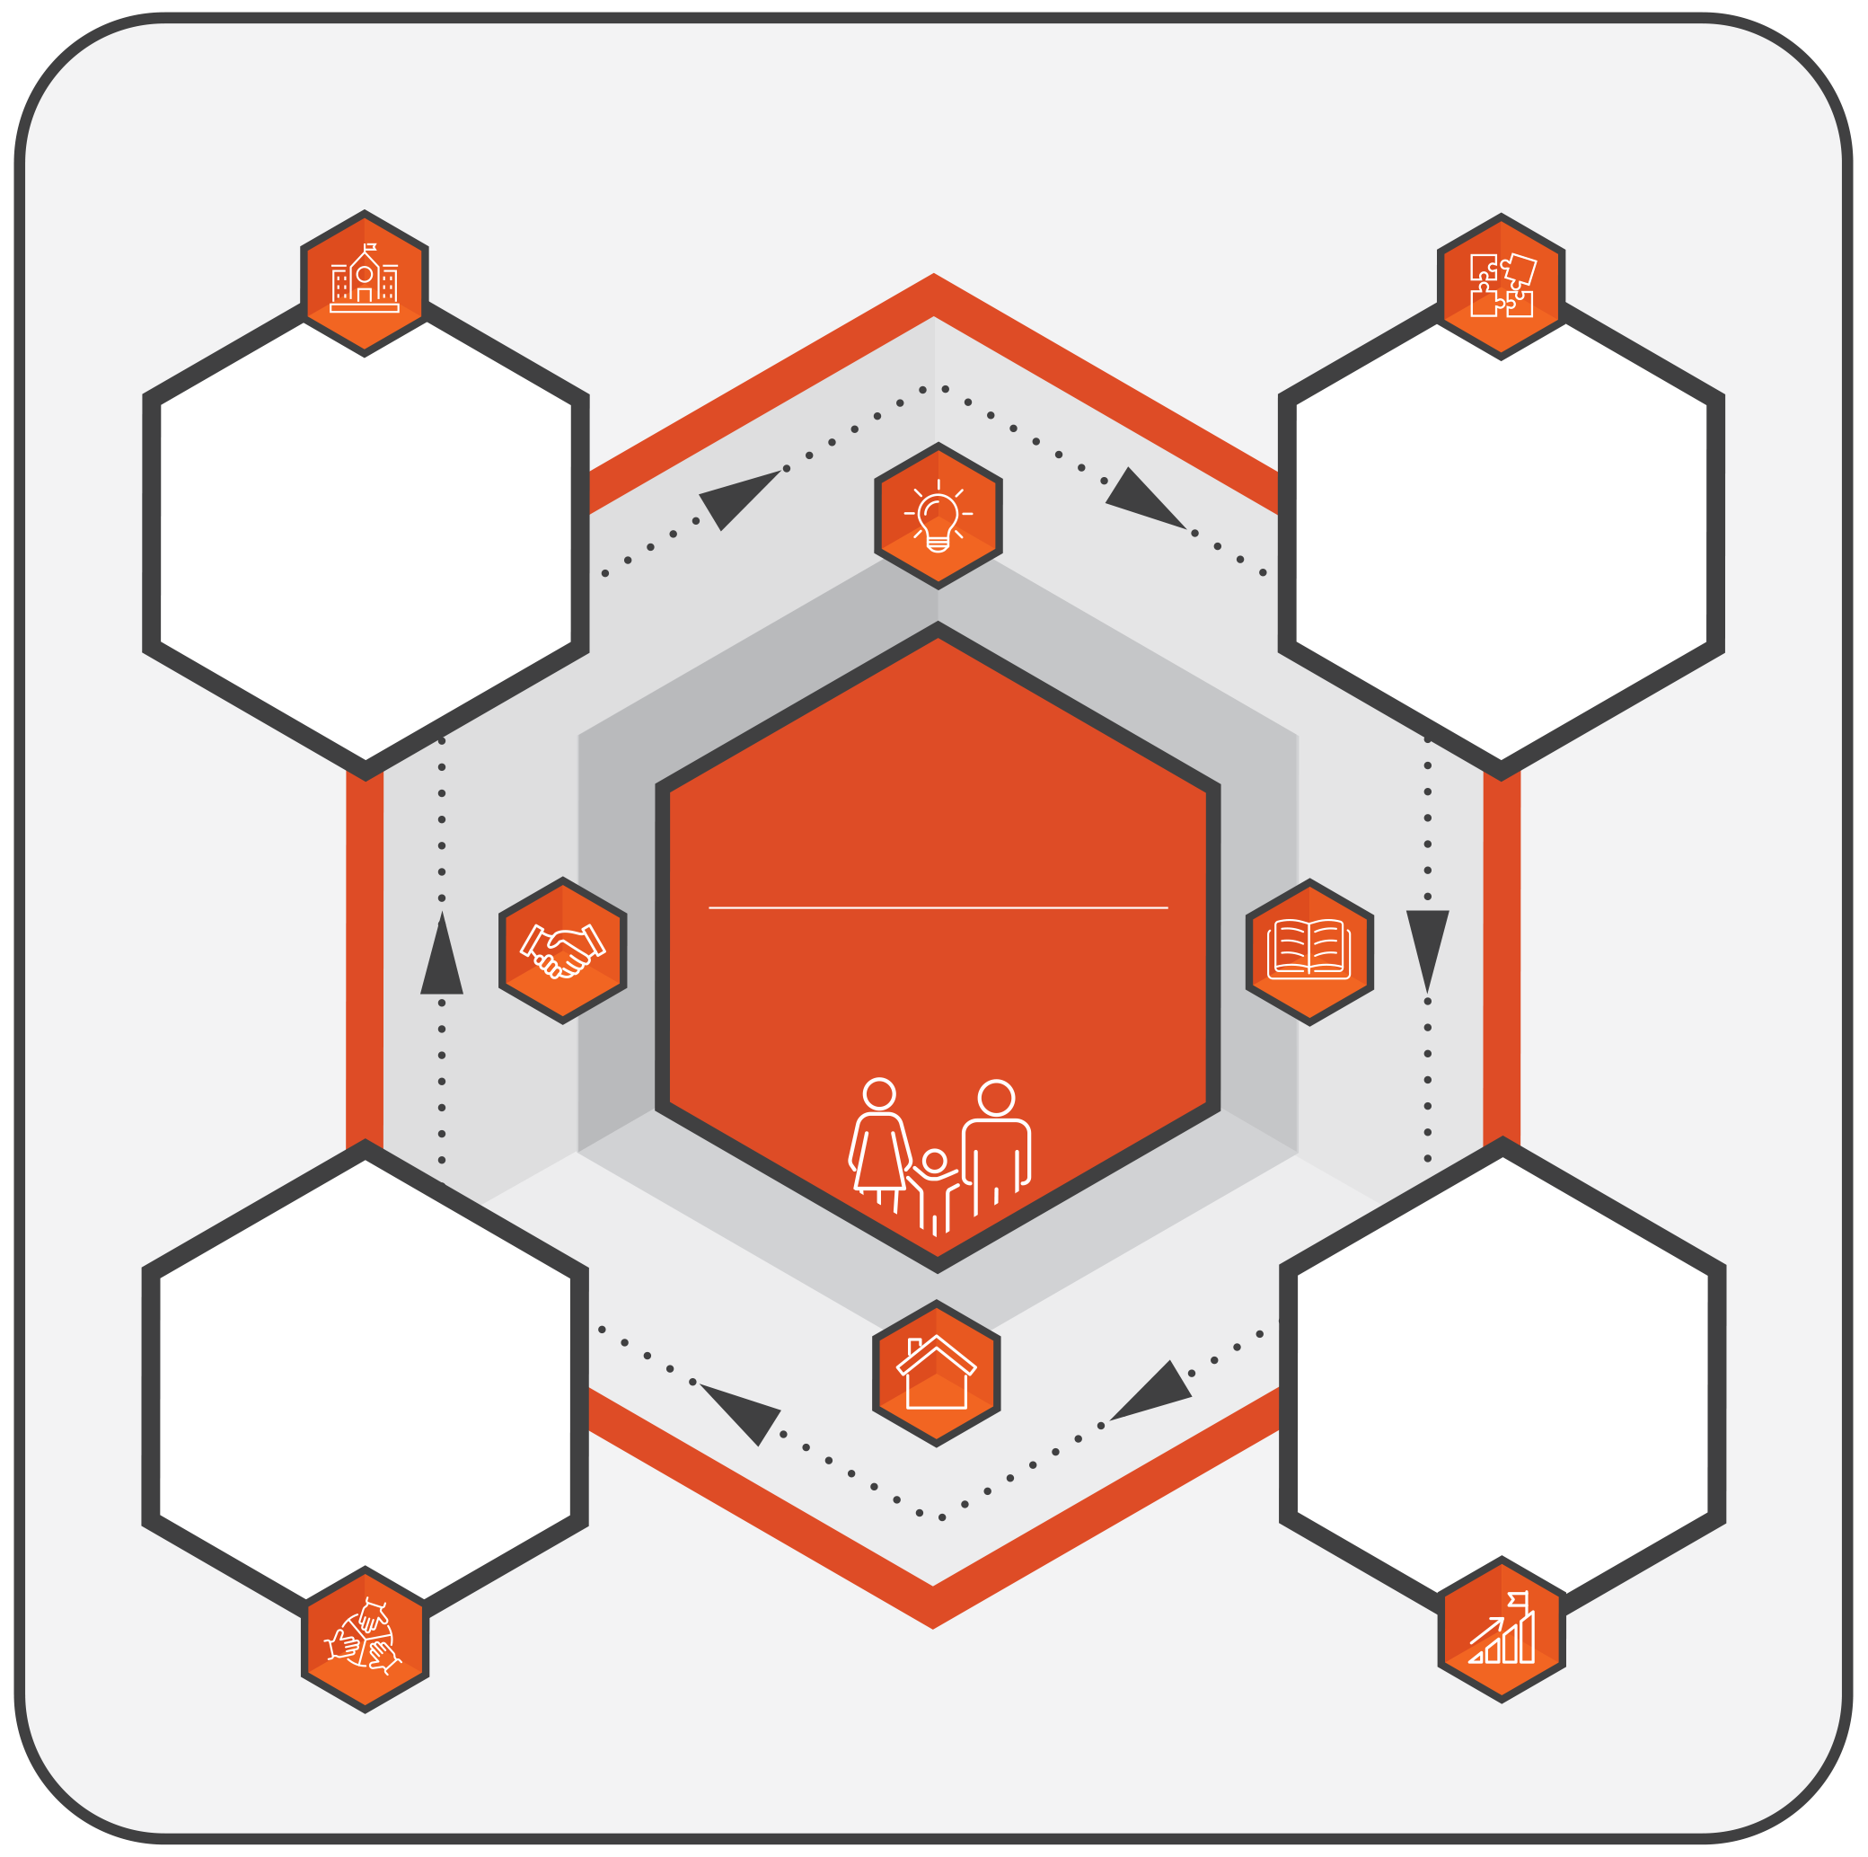
LFSA
LEARNERS AND FAMILIES SHAPING ACTION
EXPLORE CURRENT PRACTICES
How do partnerships work now?
FROM REFLECTION TO ACTION: STRENGTHENING PARTNERSHIPS
STRENGTHEN PARTNERSHIPS IN PRACTICE
Turning reflections into action
PLAN NEXT STEPS
What are realistic priorities for improvement?
IDENTIFY STRENGTHS AND GAPS
What works well and what needs strengthening?
Figure 3. Purpose of the tool


Decision-makers’ level
This section supports decision-makers to reflect on how legislation, governance, funding, accountability, capacity building and communication promote meaningful partnerships across the education system. It focuses on co-ordination within and across ministries, engagement with schools, families, learners and communities, and support for capacity building at all levels.
Decision-makers may use this section in full or in part, adapting questions and language to fit their policy cycles, structures and priorities.

Area 1: Legislation and policy


Goal 1.1: Rights-based legislative and policy framework for partnerships (aligned with conventions)
Guiding question   | Prompt(s)  (Optional cues to guide reflection) | Current status  (Please rate performance on each area using the scale provided below) | Comments/evidence  (Brief examples or references that support your answer, e.g. national policy text, law, strategy, consultation minutes, monitoring report)
1.1a Is there a national law or policy that provides a single rights-based framework for inclusive education that requires partnerships with all actors? | Think of the most recent laws or policies that require partner participation (e.g. national strategy, education act). Do they explicitly mention hard-to-reach groups? | 0 = Not developed  1 = Initiated  2 = Developing  3 = Established
1.1b Are there mandatory practices or monitoring mechanisms to ensure that partnership requirements are applied in practice? | Think of examples of mandatory practices or monitoring mechanisms (e.g. reporting requirements, inspection criteria) that aim to ensure partnership requirements in practice. | 0 = Not developed  1 = Initiated  2 = Developing  3 = Established
1.1c Do policies reference international and European Union conventions (e.g. United Nations Convention on the Rights of the Child, United Nations Convention on the Rights of Persons with Disabilities) when setting partnership requirements? | Think of examples where policy or monitoring reports explicitly mention conventions on participation. | 0 = Not developed  1 = Initiated  2 = Developing  3 = Established

Goal 1.2: Curriculum flexibility, accessibility, inclusive assessment and post-school pathways
Guiding question | Prompt(s)  (Optional cues to guide reflection) | Current status  (Please rate performance on each area using the scale provided below) | Comments/evidence  (Brief examples or references that support your answer, e.g. national policy text, law, strategy, consultation minutes, monitoring report)
1.2a Are there processes or structures in place that facilitate partners’ involvement in designing an accessible and flexible curriculum for all learners? | Think of examples of how families, learners, schools or communities are engaged in designing or revising the curriculum, including outreach to hard-to-reach groups. | 0 = Not developed  1 = Initiated  2 = Developing  3 = Established
1.2b Do you provide opportunities for partners to contribute to curriculum design and implementation to reduce barriers? | Think of examples where partner input shaped a curriculum review or change that helped reduce barriers. | 0 = Not developed  1 = Initiated  2 = Developing  3 = Established
1.2c Do you provide opportunities for partners to influence assessment practices (e.g. adapting assessments to meet individual learners’ needs)? | Think of examples where families, learners or schools influenced national assessment guidelines or practices. | 0 = Not developed  1 = Initiated  2 = Developing  3 = Established
1.2d Do you provide opportunities for partners to contribute to shaping inclusive assessment practices? | Think of examples where families, learners, schools or communities influenced assessment design, implementation or monitoring. | 0 = Not developed  1 = Initiated  2 = Developing  3 = Established
1.2e Do you ensure that curriculum and assessment policies provide opportunities for partners’ involvement at all stages, including preparation for post-school pathways (further/higher/vocational education, employment)? | How are families, learners, schools and communities supported to engage in shaping transitions and post-school pathway policies? | 0 = Not developed  1 = Initiated  2 = Developing  3 = Established

Goal 1.3: Participation of partners in national policy and curriculum development
Guiding question | Prompt(s)  (Optional cues to guide reflection) | Current status  (Please rate performance on each area using the scale provided below) | Comments/evidence  (Brief examples or references that support your answer, e.g. national policy text, law, strategy, consultation minutes, monitoring report)
1.3a Are there opportunities for partner participation in national policy development processes (e.g. consultations, public discussions)? | Identify where partner participation is explicitly required in policy development. | 0 = Not developed  1 = Initiated  2 = Developing  3 = Established
1.3b Are there opportunities for partner participation in curriculum review (e.g. consultations, feedback mechanisms for collecting learners’ and families’ views)? | Identify where partner participation is explicitly required in curriculum review processes. | 0 = Not developed  1 = Initiated  2 = Developing  3 = Established

Goal 1.4: Cross-ministerial coherence of partnership policies
Guiding question | Prompt(s)  (Optional cues to guide reflection) | Current status  (Please rate performance on each area using the scale provided below) | Comments/evidence  (Brief examples or references that support your answer, e.g. national policy text, law, strategy, consultation minutes, monitoring report)
1.4a Do the ethos and internal working processes of ministries/relevant decision-makers and sectors (e.g. education, health, social affairs, migration) consistently reflect partnership principles? | Think of examples where the internal working processes and ethos guidelines of your ministry/relevant decision-makers, other ministries/relevant decision-makers and relevant sectors (e.g. health, social affairs) address partnership principles. | 0 = Not developed  1 = Initiated  2 = Developing  3 = Established

Goal 1.5: Safeguards against exclusionary practices
Guiding question | Prompt(s)  (Optional cues to guide reflection) | Current status  (Please rate performance on each area using the scale provided below) | Comments/evidence  (Brief examples or references that support your answer, e.g. national policy text, law, strategy, consultation minutes, monitoring report)
1.5a Do policies include measures to reach all groups of partners by providing accessible means of participation? | Reflect on whether policies include clear outreach requirements or accessible formats for participation (e.g. translation, easy-to-read, community-based approaches). | 0 = Not developed  1 = Initiated  2 = Developing  3 = Established
1.5b Do policies offer supportive alternatives for hard-to-reach families and communities, co-designed with the relevant partners? | Think of examples where supportive alternatives were developed together with partners (e.g. home visits, community-based meetings, digital tools, welcoming culture brokers/liaisons). | 0 = Not developed  1 = Initiated  2 = Developing  3 = Established

Area 2: Governance

Goal 2.1: Clear governance roles and responsibilities for partnership engagement and decision-making
Guiding question | Prompt(s)  (Optional cues to guide reflection) | Current status  (Please rate performance on each area using the scale provided below) | Comments/evidence  (Brief examples or references that support your answer, e.g. national policy text, law, strategy, consultation minutes, monitoring report)
2.1a Do governance documents (laws, strategies, regulations) set out clearly assigned responsibilities for engaging partners in decision-making? | Identify laws, strategies, plans or regulations that specify who is responsible for partner engagement in decision-making at different levels (e.g. national = strategy, regional = co-ordination, local = consultation). | 0 = Not developed  1 = Initiated  2 = Developing  3 = Established
2.1b Do governance responsibilities explicitly include outreach to hard-to-reach families and learners? | Think of examples where outreach to under-represented groups is explicitly mentioned (e.g. targeted participation frameworks, outreach clauses, implicit bias training). | 0 = Not developed  1 = Initiated  2 = Developing  3 = Established
2.1c Are there procedures or structures in place that partners can use to raise complaints or disputes if they feel excluded from governance? | Think of examples of complaints or appeal mechanisms available to partners (e.g. ombudsman, grievance procedure, quality assurance appeal process). | 0 = Not developed  1 = Initiated  2 = Developing  3 = Established
2.1d Are there processes in place for decision-makers to reflect on and address their own implicit biases and how these may influence partnership decisions and resource allocation? | Think of training, reflective processes, peer review or checks that help identify biases related to socio-economic status, ethnicity, disability, language, family structure or migration background. | 0 = Not developed  1 = Initiated  2 = Developing  3 = Established

Goal 2.2: Mechanisms for partner representation and influence in governance structures
Guiding question | Prompt(s)  (Optional cues to guide reflection) | Current status  (Please rate performance on each area using the scale provided below) | Comments/evidence  (Brief examples or references that support your answer, e.g. national policy text, law, strategy, consultation minutes, monitoring report)
2.2a Do governance structures in your ministry/department include formal mechanisms to represent partners (e.g. advisory councils, boards, working groups)? | Identify governance structures where partners are formally represented (e.g. advisory council, parent/learner committee, national working group). | 0 = Not developed  1 = Initiated  2 = Developing  3 = Established
2.2b Do governance documents specify how partner representatives are selected and supported in their roles? | Think of examples of rules or guidelines on selection/support (e.g. selection procedure, rotation mechanism, training). | 0 = Not developed  1 = Initiated  2 = Developing  3 = Established
2.2c Do governance structures include measures to ensure the participation of hard-to-reach families and learners? | Think of examples of measures designed to include under-represented groups (e.g. outreach via community organisations, reserved seats, targeted recruitment). | 0 = Not developed  1 = Initiated  2 = Developing  3 = Established
2.2d Do governance structures give partner representatives influence in decision-making (e.g. consultation requirements, mandatory responses, voting rights)? | Think of instances where partner input was formally considered in governance decisions (e.g. advisory recommendations acted on, required written responses). | 0 = Not developed  1 = Initiated  2 = Developing  3 = Established

Goal 2.3: Co-ordination and capacity across governance levels for partnership
Guiding question | Prompt(s)  (Optional cues to guide reflection) | Current status  (Please rate performance on each area using the scale provided below) | Comments/evidence  (Brief examples or references that support your answer, e.g. national policy text, law, strategy, consultation minutes, monitoring report)
2.3a Do you co-ordinate partnership responsibilities across governance levels (national, regional, local) to ensure coherence? | Think of examples of co-ordination mechanisms across levels (e.g. joint working groups, reporting requirements, shared frameworks). | 0 = Not developed  1 = Initiated  2 = Developing  3 = Established
2.3b Do you provide guidance or support to regional and local levels on how to engage partners? | Think of types of guidance or support provided on how to engage partners at regional and local levels (e.g. training, handbooks, dedicated staff). | 0 = Not developed  1 = Initiated  2 = Developing  3 = Established
2.3c Do you allocate resources (financial, technical or human) to strengthen capacity for partner engagement at all levels? | Think of examples of resources provided to foster partner engagement (e.g. budget line for family engagement, staff roles, technical support). | 0 = Not developed  1 = Initiated  2 = Developing  3 = Established
2.3d Are there mechanisms to ensure that feedback from partners at regional or local levels is communicated to higher levels? | Think of examples of how partner feedback from regional/local consultations is reported upwards (e.g. regional reports including family/learner perspectives, community consultation summaries). | 0 = Not developed  1 = Initiated  2 = Developing  3 = Established

Area 3: Funding and resource allocation

Goal 3.1: Flexible funding mechanisms that enable partnership action
Guiding question | Prompt(s)  (Optional cues to guide reflection) | Current status  (Please rate performance on each area using the scale provided below) | Comments/evidence  (Brief examples or references that support your answer, e.g. national policy text, law, strategy, consultation minutes, monitoring report)
3.1a Are there funding rules or guidelines that explicitly state the resources that can be used for partnership activities (e.g. translation, community liaison roles, outreach, learner-voice structures, teacher release time)? | Think of funding rules, guidelines or allocations that make partnership uses explicit (e.g. grant line for liaison staff, flexibility in school budgets, teacher release time). How are these communicated to the partners? | 0 = Not developed  1 = Initiated  2 = Developing  3 = Established
3.1b Is there dedicated funding for teacher professional learning (TPL) that aims to strengthen teachers’ ability to build and sustain partnerships with families, learners, schools and communities? | Think of TPL programmes, grants or budget lines that focus on partnership skills (e.g. family–school collaboration, learner participation, community engagement, implicit bias training). Does the funding specifically aim to strengthen teachers’ ability to work with partners? Is the funding on-going or one-off? | 0 = Not developed  1 = Initiated  2 = Developing  3 = Established
3.1c Are there funding rules that permit schools and local actors to access or reallocate discretionary funds in a timely way to respond to emerging partnership needs, while requiring accountability for their use? | Think of instances where funding is adapted, reallocated or repurposed in response to partnership needs (e.g. shifting funds to translation, mediation or outreach when barriers emerge). How is the funding claimed and reported (e.g. simple reporting, approval process)? | 0 = Not developed  1 = Initiated  2 = Developing  3 = Established

Goal 3.2: Clarity and accessibility of funding processes for partnerships
Guiding question | Prompt(s)  (Optional cues to guide reflection) | Current status  (Please rate performance on each area using the scale provided below) | Comments/evidence  (Brief examples or references that support your answer, e.g. national policy text, law, strategy, consultation minutes, monitoring report)
3.2a Are the criteria for allocating resources to partnerships clear and accessible to all partners? | Think of published criteria or guidance notes (e.g. circulars, allocation guidelines). Are these shared in formats that are accessible to non-technical audiences (e.g. plain-language summaries, translations, community-friendly formats, paper versions, etc.)? | 0 = Not developed  1 = Initiated  2 = Developing  3 = Established
3.2b Do you communicate funding decisions for partnership activities in formats that schools, families, learners and communities can understand and use? | Think of how funding decisions are shared (e.g. community meetings, simplified guidance, multi-lingual updates). How do you check whether partners understand and use this information (e.g. follow-up meetings, feedback forms)? | 0 = Not developed  1 = Initiated  2 = Developing  3 = Established
3.2c Are there mechanisms for partners to provide feedback or raise concerns about how partnership resources are allocated? | Think of consultation or feedback mechanisms (e.g. advisory groups, consultation windows, forums). Are there formal processes to respond to partners’ feedback (e.g. written replies, published summaries)? | 0 = Not developed  1 = Initiated  2 = Developing  3 = Established

Goal 3.3: Equity-oriented and targeted funding to support partnerships and reach hard-to-reach groups
Guiding question | Prompt(s)  (Optional cues to guide reflection) | Current status  (Please rate performance on each area using the scale provided below) | Comments/evidence  (Brief examples or references that support your answer, e.g. national policy text, law, strategy, consultation minutes, monitoring report)
3.3a Are there targeted funds or allocations that explicitly prioritise schools, families, learners and communities at greater risk of exclusion? | Think of targeted funds, grants or allocation formulas that direct resources to hard-to-reach groups (e.g. socio-economic weighting, rural/remote support, migrant or disability outreach). | 0 = Not developed  1 = Initiated  2 = Developing  3 = Established
3.3b Are there mechanisms to allocate resources that directly support outreach and engagement of hard-to-reach families and learners as part of partnerships? | Think of examples where funding is used for outreach roles, initiatives or tools (e.g. home–school liaison, translation, accessible information, community engagement staff). Is this funding on-going or one-off? | 0 = Not developed  1 = Initiated  2 = Developing  3 = Established
3.3c Do you monitor whether targeted funds/resources actually reach and benefit the intended families, learners, schools and communities, and contribute to stronger partnerships? | Think of monitoring or reporting processes that check whether targeted resources benefit intended groups (e.g. disaggregated participation data, outreach impact reports, evaluation findings). | 0 = Not developed  1 = Initiated  2 = Developing  3 = Established

Area 4: Quality assurance, accountability and system data

Goal 4.1: Monitoring, reporting and accountability for partnership-related resource use
Guiding question | Prompt(s)  (Optional cues to guide reflection) | Current status  (Please rate performance on each area using the scale provided below) | Comments/evidence  (Brief examples or references that support your answer, e.g. national policy text, law, strategy, consultation minutes, monitoring report)
4.1a Are there mechanisms to monitor whether resources allocated for partnerships are spent according to national rules and intended purposes? | Think of monitoring or review mechanisms (e.g. annual reports, audits, inspection criteria) that check whether partnership-related resources have been used as planned (e.g. liaison roles, outreach). | 0 = Not developed  1 = Initiated  2 = Developing  3 = Established
4.1b Do you require public reporting back to partners on how resources for partnerships are used? | Think of examples where partnership expenditure figures are made public or shared with partners in accessible formats (e.g. community-friendly financial summaries, multi-lingual newsletters, published expenditure reports, websites, consultation briefings). | 0 = Not developed  1 = Initiated  2 = Developing  3 = Established
4.1c Do you evaluate whether resources allocated for partnerships achieve their intended outcomes? | Think of evaluations or reviews that look at the outcomes of expenditure (e.g. did outreach budgets increase family participation?). | 0 = Not developed  1 = Initiated  2 = Developing  3 = Established

Goal 4.2: Ensuring that resources reach and benefit hard-to-reach groups
Guiding question | Prompt(s)  (Optional cues to guide reflection) | Current status  (Please rate performance on each area using the scale provided below) | Comments/evidence  (Brief examples or references that support your answer, e.g. national policy text, law, strategy, consultation minutes, monitoring report)
4.2a Are there monitoring systems to check whether partnership resources actually reach those families and learners most at risk of exclusion? | Think of monitoring mechanisms or datasets (e.g. disaggregated participation data, outreach tracking reports) that check reach for migrant families, learners with disabilities, rural communities or linguistic minorities. | 0 = Not developed  1 = Initiated  2 = Developing  3 = Established
4.2b Are there mechanisms to evaluate whether resources for hard-to-reach families and learners are adequate and effective in meeting their needs? | Think of evaluations or reviews where adequacy/effectiveness of support is assessed (e.g. translation services, transport subsidies, funding for outreach staff, accessible communication tools). | 0 = Not developed  1 = Initiated  2 = Developing  3 = Established
4.2c Do you involve families, learners, schools and communities in assessing whether resources for hard-to-reach groups are sufficient and meaningful? | Think of cases where partners have the opportunity to give feedback on sufficiency/impact (e.g. surveys, focus groups, consultation reports). | 0 = Not developed  1 = Initiated  2 = Developing  3 = Established

Goal 4.3: Collecting data on the sufficiency and quality of partner engagement
Guiding question | Prompt(s)  (Optional cues to guide reflection) | Current status  (Please rate performance on each area using the scale provided below) | Comments/evidence  (Brief examples or references that support your answer, e.g. national policy text, law, strategy, consultation minutes, monitoring report)
4.3a Do you collect data that ensures representation of diverse groups of partners (ethnic/linguistic/cultural groups, etc.) on whether engagement opportunities are accessible and sufficient? | Think of mechanisms (e.g. surveys, focus groups, consultation reports) that ask whether partners can access and use engagement opportunities. | 0 = Not developed  1 = Initiated  2 = Developing  3 = Established
4.3b Is partner engagement monitored and evaluated to assess sufficiency, quality and impact? | Think of participation records, partner feedback, meeting summaries or brief reports showing sufficiency, quality and impact of engagement. | 0 = Not developed  1 = Initiated  2 = Developing  3 = Established

Goal 4.4: Evaluating the impact of partnership involvement on decision-making
Guiding question | Prompt(s)  (Optional cues to guide reflection) | Current status  (Please rate performance on each area using the scale provided below) | Comments/evidence  (Brief examples or references that support your answer, e.g. national policy text, law, strategy, consultation minutes, monitoring report)
4.4a Are there evaluation mechanisms to review and act on partners’ feedback? | Think of examples where recommendations were tracked through to final outcomes (e.g. curriculum reform, new regulation, revised strategy). | 0 = Not developed  1 = Initiated  2 = Developing  3 = Established
4.4b Are feedback channels accessible, safe and trusted by all partners? | Think of surveys, consultations or anonymous feedback mechanisms, and whether certain aspects are considered, including ease of access, confidentiality and regular use by partners. | 0 = Not developed  1 = Initiated  2 = Developing  3 = Established

Area 5: Capacity building and inclusive leadership

Goal 5.1: Embedding partnership in the vision for teacher professional learning (TPL)
Guiding question | Prompt(s)  (Optional cues to guide reflection) | Current status  (Please rate performance on each area using the scale provided below) | Comments/evidence  (Brief examples or references that support your answer, e.g. national policy text, law, strategy, consultation minutes, monitoring report)
5.1a Does the vision for TPL state that building partnerships with families, learners, schools and communities is crucial? | Think of instances where the vision for TPL explicitly highlights partnership competences (e.g. family engagement, learner participation, community collaboration). | 0 = Not developed  1 = Initiated  2 = Developing  3 = Established
5.1b Are initial teacher education (ITE) programmes required to prepare student teachers to build partnerships with families and learners and engage with those who are often hard to reach (e.g. migrant families, learners with disabilities, rural dwellers or linguistic minorities)? | Think of examples of ITE content (standards, accreditation criteria, curriculum) or placements that support student teachers with how to build partnerships and specifically address barriers faced by marginalised partners (e.g. multi-lingual communication, disability-inclusive strategies, rural outreach). | 0 = Not developed  1 = Initiated  2 = Developing  3 = Established
5.1c Are there any requirements for ITE graduates to demonstrate partnership competences during induction or at the beginning of their in-service career? | Think of assessment or review processes that require graduates to demonstrate partnership-building skills (e.g. graduate surveys, induction feedback, accreditation reviews). | 0 = Not developed  1 = Initiated  2 = Developing  3 = Established

Goal 5.2: Continuous professional development (CPD) for partnership competences
Guiding question | Prompt(s)  (Optional cues to guide reflection) | Current status  (Please rate performance on each area using the scale provided below) | Comments/evidence  (Brief examples or references that support your answer, e.g. national policy text, law, strategy, consultation minutes, monitoring report)
5.2a Do CPD opportunities for teachers, specialists and other school staff (e.g. administrative assistants, janitors) explicitly target skills for building and sustaining partnerships with families, learners, schools and communities? | Think of CPD structures, courses or grants that cover partnership competences (e.g. family–school collaboration, learner participation, community engagement, training for administrative staff to welcome families, training to reduce bias towards non-dominant groups in the school community). | 0 = Not developed  1 = Initiated  2 = Developing  3 = Established
5.2b Are there mechanisms in place to adapt CPD opportunities to the needs of partners in local contexts (e.g. rural areas, migrant communities, disability inclusion, multi-lingual families)? | Think of CPD programmes or modules that aim to respond to local partnership needs (e.g. rural outreach training, multi-lingual communication workshops, disability-inclusive pedagogy, migrant family engagement strategies). | 0 = Not developed  1 = Initiated  2 = Developing  3 = Established
5.2c Are there mechanisms in place that track participation in and the effectiveness of CPD programmes on partnership (e.g. who attends, what changes result)? | Think of evaluation or monitoring systems that check whether CPD on partnership reaches the intended staff and improves practices (e.g. participant tracking, evaluation reports, follow-up reviews, impact studies, feedback from families). | 0 = Not developed  1 = Initiated  2 = Developing  3 = Established
5.2d Does TPL target partnership competences across the professional continuum? | Think of national strategies, vision documents or CPD frameworks where partnership competences are embedded across TPL and on-going professional learning (e.g. national teacher standards, partnership-focused CPD priorities). | 0 = Not developed  1 = Initiated  2 = Developing  3 = Established

Goal 5.3: Leadership CPD to strengthen a culture of partnership
Guiding question | Prompt(s)  (Optional cues to guide reflection) | Current status  (Please rate performance on each area using the scale provided below) | Comments/evidence  (Brief examples or references that support your answer, e.g. national policy text, law, strategy, consultation minutes, monitoring report)
5.3a Are there CPD programmes for educational leaders (e.g. school principals, regional co-ordinators) that explicitly aim to build skills for working in partnership with families, learners, schools and communities? | Think of CPD programmes or leadership frameworks that include modules on family–school collaboration, learner participation or community engagement. | 0 = Not developed  1 = Initiated  2 = Developing  3 = Established
5.3b Are there explicit standards set for leaders to co-ordinate inclusive partnership practices? | Think of leadership standards, job descriptions or appraisal processes that make partnership competences part of leader responsibilities (e.g. mentoring staff on outreach, engaging families in governance). | 0 = Not developed  1 = Initiated  2 = Developing  3 = Established
5.3c Are there processes in place for school staff to reflect on and address their own implicit biases and how these may influence partnership efforts? | Think of ways in which assumptions about families’, learners’ or communities’ ‘capacity’ or ‘willingness’ to engage are questioned or challenged. | 0 = Not developed  1 = Initiated  2 = Developing  3 = Established
5.3d Are there CPD options for leaders that support them to engage with families and learners who are at greater risk of exclusion as equal partners (e.g. migrant families, learners with disabilities, rural communities, linguistic minorities, low socio-economic status groups, those with intersectional barriers)? | Think of CPD content, frameworks or standards that emphasise equity in partnership (e.g. leaders trained to support inclusive outreach, monitor equity impacts or adapt processes for hard-to-reach groups). | 0 = Not developed  1 = Initiated  2 = Developing  3 = Established

Goal 5.4: Building ministry and partner capacity for partnership
Guiding question | Prompt(s)  (Optional cues to guide reflection) | Current status  (Please rate performance on each area using the scale provided below) | Comments/evidence  (Brief examples or references that support your answer, e.g. national policy text, law, strategy, consultation minutes, monitoring report)
5.4a Are there CPD opportunities for national and regional staff on how to self-reflect, design and implement policies that engage families, learners, schools and communities? | Think of CPD, seminars, workshops or peer exchanges offered to ministry/department of education employees on participatory policy design, community engagement or partnership monitoring. | 0 = Not developed  1 = Initiated  2 = Developing  3 = Established
5.4b Are there opportunities for-departmental learning and exchanges to strengthen partnership capacity across sectors (e.g. education, health, social affairs, migration)? | Think of initiatives where different departments collaborate to improve partnership practices (e.g. joint training, multi-sectoral workshops, shared guidance). | 0 = Not developed  1 = Initiated  2 = Developing  3 = Established
5.4c Are there dedicated resources or support to strengthen the capacity of families, learners, schools and communities to engage effectively in partnership processes? | Think of examples where partners are supported to participate (e.g. parent leadership programmes, learner councils with training, plain-language guides, facilitation for community engagement). | 0 = Not developed  1 = Initiated  2 = Developing  3 = Established
5.4d Are there mechanisms to monitor whether capacity-building initiatives for both staff and partners lead to more effective and equitable partnerships? | Think of reviews or evaluations that assess whether staff training or partner capacity building improve collaboration, inclusiveness or decision-making outcomes. | 0 = Not developed  1 = Initiated  2 = Developing  3 = Established

Area 6: Collaboration, communication and school-level co-operation

Goal 6.1: Intra- and inter-ministerial co-ordination for partnerships
Guiding question | Prompt(s)  (Optional cues to guide reflection) | Current status  (Please rate performance on each area using the scale provided below) | Comments/evidence  (Brief examples or references that support your answer, e.g. national policy text, law, strategy, consultation minutes, monitoring report)
6.1a Are there processes in place to foster intra- and inter-ministerial collaboration on partnership-related work (across offices inside the ministry)? | Think of mechanisms or practices (e.g. internal working group, joint planning meetings, cross-department reporting templates) that ensure consistency on partnership-related work within the ministry/among relevant decision-makers. | 0 = Not developed  1 = Initiated  2 = Developing  3 = Established
6.1b Are there mechanisms in place to review and evaluate whether intra- and inter-ministerial co-ordination improves partnership outcomes? | Think of evaluations, reviews or feedback processes that assess whether co-ordination improves partnership outcomes (e.g. reduced duplication, stronger outreach, more coherent policy implementation). | 0 = Not developed  1 = Initiated  2 = Developing  3 = Established

Goal 6.2: On-going dialogue with schools, families, learners, communities and all education staff
Guiding question | Prompt(s)  (Optional cues to guide reflection) | Current status  (Please rate performance on each area using the scale provided below) | Comments/evidence  (Brief examples or references that support your answer, e.g. national policy text, law, strategy, consultation minutes, monitoring report)
6.2a Are there regular mechanisms to communicate partnership priorities and guidance to schools, families, learners and communities? | Think of regular communication channels (e.g. circulars, newsletters, community meetings, online platforms) that explain partnership priorities in accessible ways. | 0 = Not developed  1 = Initiated  2 = Developing  3 = Established
6.2b Are there structured mechanisms for co-operation with schools (e.g. regular meetings with school boards, principal associations or school networks)? | Think of examples where the ministry/relevant decision-makers work directly with schools to shape partnership priorities or address challenges. | 0 = Not developed  1 = Initiated  2 = Developing  3 = Established

Goal 6.3: Trusted channels for families, learners, schools and communities to raise concerns or feedback
Guiding question | Prompt(s)  (Optional cues to guide reflection) | Current status  (Please rate performance on each area using the scale provided below) | Comments/evidence  (Brief examples or references that support your answer, e.g. national policy text, law, strategy, consultation minutes, monitoring report)
6.3a Are channels for raising concerns or feedback designed to be inclusive and accessible to all partners, especially those at risk of exclusion (e.g. multi-lingual, disability access, offline options)? | Think of examples of accessibility features in practice (e.g. translation/interpretation, telephone and in-person options, assistive technology, community help desks). | 0 = Not developed  1 = Initiated  2 = Developing  3 = Established
6.3b Are there mechanisms in place to report back on how partners’ input is used in decision-making? | Think of follow-up emails, summaries, reports or meetings that explain how partners’ input informed decisions or actions. | 0 = Not developed  1 = Initiated  2 = Developing  3 = Established

The term ‘cross-ministerial’ is used for consistency, as in most EASNIE member countries decision-making responsibilities lie at ministerial level. In other national contexts, equivalent responsibilities may sit within departments, local or regional authorities, municipalities, cantons or other governing bodies.

