Self-Reflection Tool on Partnerships in Education
Communities
European Agency for Special Needs and Inclusive Education

The European Agency for Special Needs and Inclusive Education (EASNIE) is an independent and self-governing organisation. EASNIE is co-funded by the ministries of education in its member countries and by the European Commission via an operating grant within the European Union (EU) education programme.

Funded by the European Union. Views and opinions expressed are however those of the author(s) only and do not necessarily reflect those of the European Union or the European Commission. Neither the European Union nor the European Commission can be held responsible for them.

The views expressed by any individual in this document do not necessarily represent the official views of EASNIE, its member countries or the European Commission.
© European Agency for Special Needs and Inclusive Education 2025
Editors: Pamela Zoe Topalli, Antonella Mangiaracina and Katherina Alvarez
This publication is an open-source resource. This means you are free to access, use, modify and disseminate it with appropriate credit to the European Agency for Special Needs and Inclusive Education. Please refer to EASNIE’s Open Access Policy for more information: www.european-agency.org/open-access-policy.
You may cite this publication as follows: European Agency for Special Needs and Inclusive Education, 2025. Self-Reflection Tool on Partnerships in Education: Communities. (P. Z. Topalli, A. Mangiaracina and K. Alvarez, eds.). Odense, Denmark


This work is licensed under a Creative Commons Attribution-NonCommercial-ShareAlike 4.0 International License.
You are free to share and adapt this publication.
With a view to greater accessibility, this report is available in accessible electronic format on EASNIE’s website: www.european-agency.org

Secretariat
Østre Stationsvej 33
DK-5000 Odense C Denmark
Tel.: +45 64 41 00 20
secretariat@european-agency.org
Brussels Office
Rue Montoyer 21
BE-1000 Brussels Belgium
Tel.: +32 2 213 62 80
brussels.office@european-agency.org

Contents
Self-reflection tool on partnerships in education 5
Purpose 5
How the tool is organised 6
Using the tool 8
Using the developmental scale 8
Reflection process 8
Key principles 8
Community level 10
Area 1: Awareness of rights, policies and shared commitments 11
Goal 1.1: Community organisations are aware of national and local partnership policies and rights frameworks 11
Goal 1.2: Community organisations share information about rights and participation with families and learners 12
Goal 1.3: Community organisations provide feedback to schools and ministries on how partnership policies affect local realities 13
Area 2: Community leadership, representation and decision-making 14
Goal 2.1: Community organisations are represented in local decision-making bodies related to education 14
Goal 2.2: Community organisations co-ordinate among themselves to bring shared priorities to schools and educational authorities 16
Goal 2.3: Community leaders promote equitable participation and model transparent governance 17
Area 3: Resources and shared infrastructure for partnership 18
Goal 3.1: Community organisations have access to spaces, staff and resources to support partnership with schools and ministries 18
Goal 3.2: Resources are used equitably to reach under-served families and learners 19
Goal 3.3: Community organisations contribute local knowledge, volunteers or in-kind resources to partnership work 20
Area 4: Learning from evidence and community insight 21
Goal 4.1: Community organisations collect feedback and participation data from families, learners and local partners 21
Goal 4.2: Community organisations analyse and discuss findings with schools and authorities to co-develop solutions 22
Goal 4.3: Community organisations share local evidence and insights with ministries and networks 23
Area 5: Building capacity and mutual learning 24
Goal 5.1: Community organisations develop their own capacity to engage effectively in education partnerships 24
Goal 5.2: Schools and community organisations create mutual learning opportunities 25
Goal 5.3: Community organisations support families and learners to build their partnership skills 26
Area 6: Communication, trust and local co-operation networks 27
Goal 6.1: Community organisations maintain regular, two-way communication with schools, families and learners 27
Goal 6.2: Community organisations ensure safe, confidential spaces for families and learners to raise concerns 29
Goal 6.3: Community organisations collaborate with schools and local services to co-ordinate joined-up support 30

Self-reflection tool on partnerships in education

Purpose
This self-reflection tool helps decision-makers, schools, communities, families and learners explore how partnerships currently work in practice and how to strengthen them. It supports users to recognise strengths, identify gaps and plan realistic next steps across six partnership areas.
It is an output from the Learners and Families Shaping Action (LFSA) activity, conducted by the European Agency for Special Needs and Inclusive Education (EASNIE).
The tool has five sections, one for each group of partners. While sections are organised by partner group, the tool should be used collaboratively wherever possible, with different perspectives informing reflection on the same areas. All five sections and the accompanying Guidance and Methodology Report are available on:
www.european-agency.org/resources/publications/LFSA-tool.
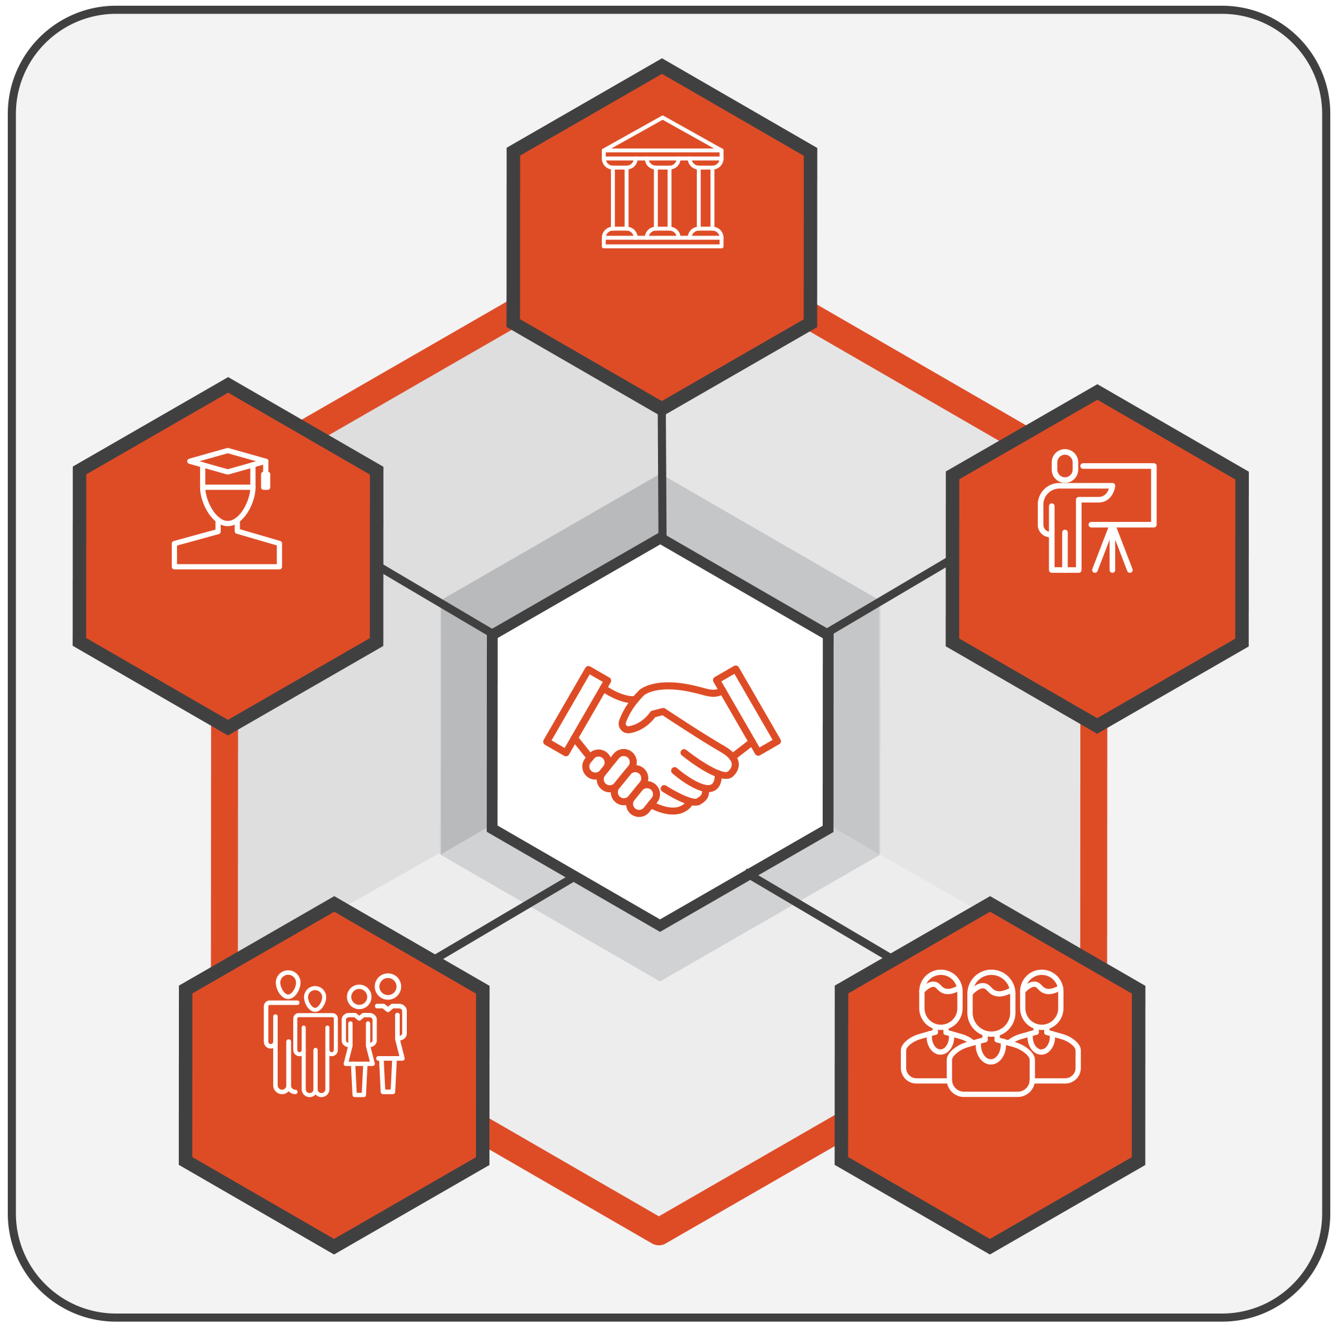
DECISION-MAKERS
LEARNERS
FAMILIES
SCHOOLS
COMMUNITIES
Figure 1. Partners

How the tool is organised
The tool has a dedicated section for each specific group of partners (decision-makers, schools, community, families, learners). Each section has the following structure:
- Area: The broad domain or theme for reflection (for example, legislation, governance, resources).
- Goal: The specific aim or expected outcome for that area.
- Guiding questions: Focused questions designed to prompt reflection and dialogue.
- Prompt(s): Optional cues that help you think more concretely about the question (for example, ‘Are there feedback channels to families?’, ‘Is learner input reflected in policy?’). Prompts aim to help guide deeper discussion.
- Current status: A four-point developmental scale showing where practice currently stands:
  - 0 = Not developed: No structures or processes in place.
  - 1 = Initiated: Early steps that often depend on individual commitment, short-term projects or specific contexts, and are not yet embedded in formal structures, procedures or resourcing.
  - 2 = Developing: Practices are becoming more coherent, responsibilities are clearer and less dependent on individual actors, and implementation is expanding across contexts. However, consistency, sustainability or system-wide reach are not yet fully ensured.
  - 3 = Established: Partnership is fully integrated, regularly reviewed and used to inform improvement.
- Comments/evidence: Short notes or examples supporting your reflection (for example, reference to a national policy, school strategy, meeting record or evaluation report). These can include both policy evidence (frameworks, regulations or formal commitments) and practice evidence (documents, actions or data showing implementation). Where relevant, you may wish to mention the source or context briefly to help track progress over time.
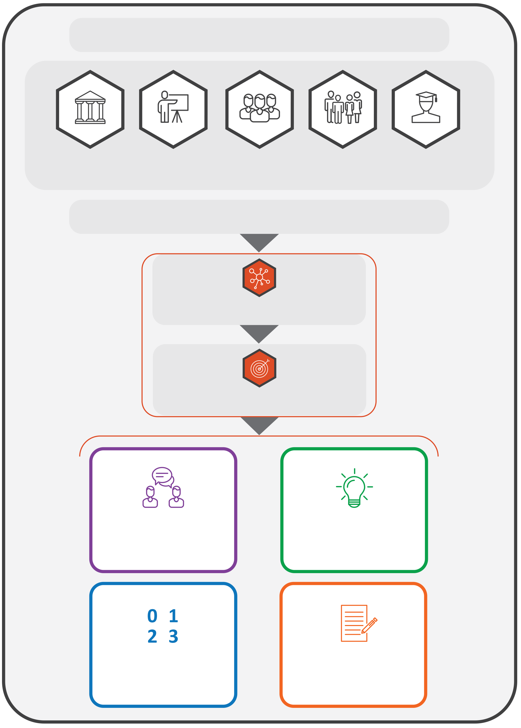
THE TOOL HAS A SECTION FOR EACH GROUP OF PARTNERS

DECISION-MAKERS
LEARNERS
FAMILIES
SCHOOLS
COMMUNITIES
EACH SECTION IS STRUCTURED AS FOLLOWS:
AREA
GOAL
GUIDING QUESTIONS
CURRENT STATUS
PROMPTS
COMMENTS/ EVIDENCE
Figure 2. Structure of the tool

Using the tool
The tool can be used to:
- support internal reflection within ministries, departments and schools;
- structure dialogue between decision-makers and partners;
- inform policy review, strategy development or funding design;
- complement existing monitoring, evaluation or peer-learning processes.

Using the developmental scale
The 0–3 scale is not for comparison or ranking. It helps users to consider where they are now and to identify realistic next steps for growth. It shows how well partnership is included in everyday practice, rather than treated as a one-off activity.

Reflection process
- Review each area and the guiding questions.
- Discuss and agree on a rating (0–3) based on the available information.
- Enter short examples or notes in the ‘Comments/evidence’ column.
- Identify two or three concrete next steps for improvement.
- Revisit periodically (for example, once a year) to monitor change and share learning.
You may choose to reflect on all six areas or focus on those most relevant to your current priorities. The tool is designed to be flexible: you may adapt the sections, questions or language to fit your context and capacity.

Key principles
- Developmental, not evaluative: The tool supports learning and improvement, not inspection.
- Collaborative: Reflection should, whenever possible, bring together multiple perspectives.
- Inclusive: All partners (decision-makers, schools, communities, families and learners) contribute to partnership quality.
- Flexible: The tool can be used in full or in part, depending on purpose and timing. Countries, regions or institutions may combine or simplify questions, focus on selected areas or adapt the format to align with national processes and capacity. It can serve as a stand-alone reflection activity, part of a peer-learning exchange or input for national reviews.
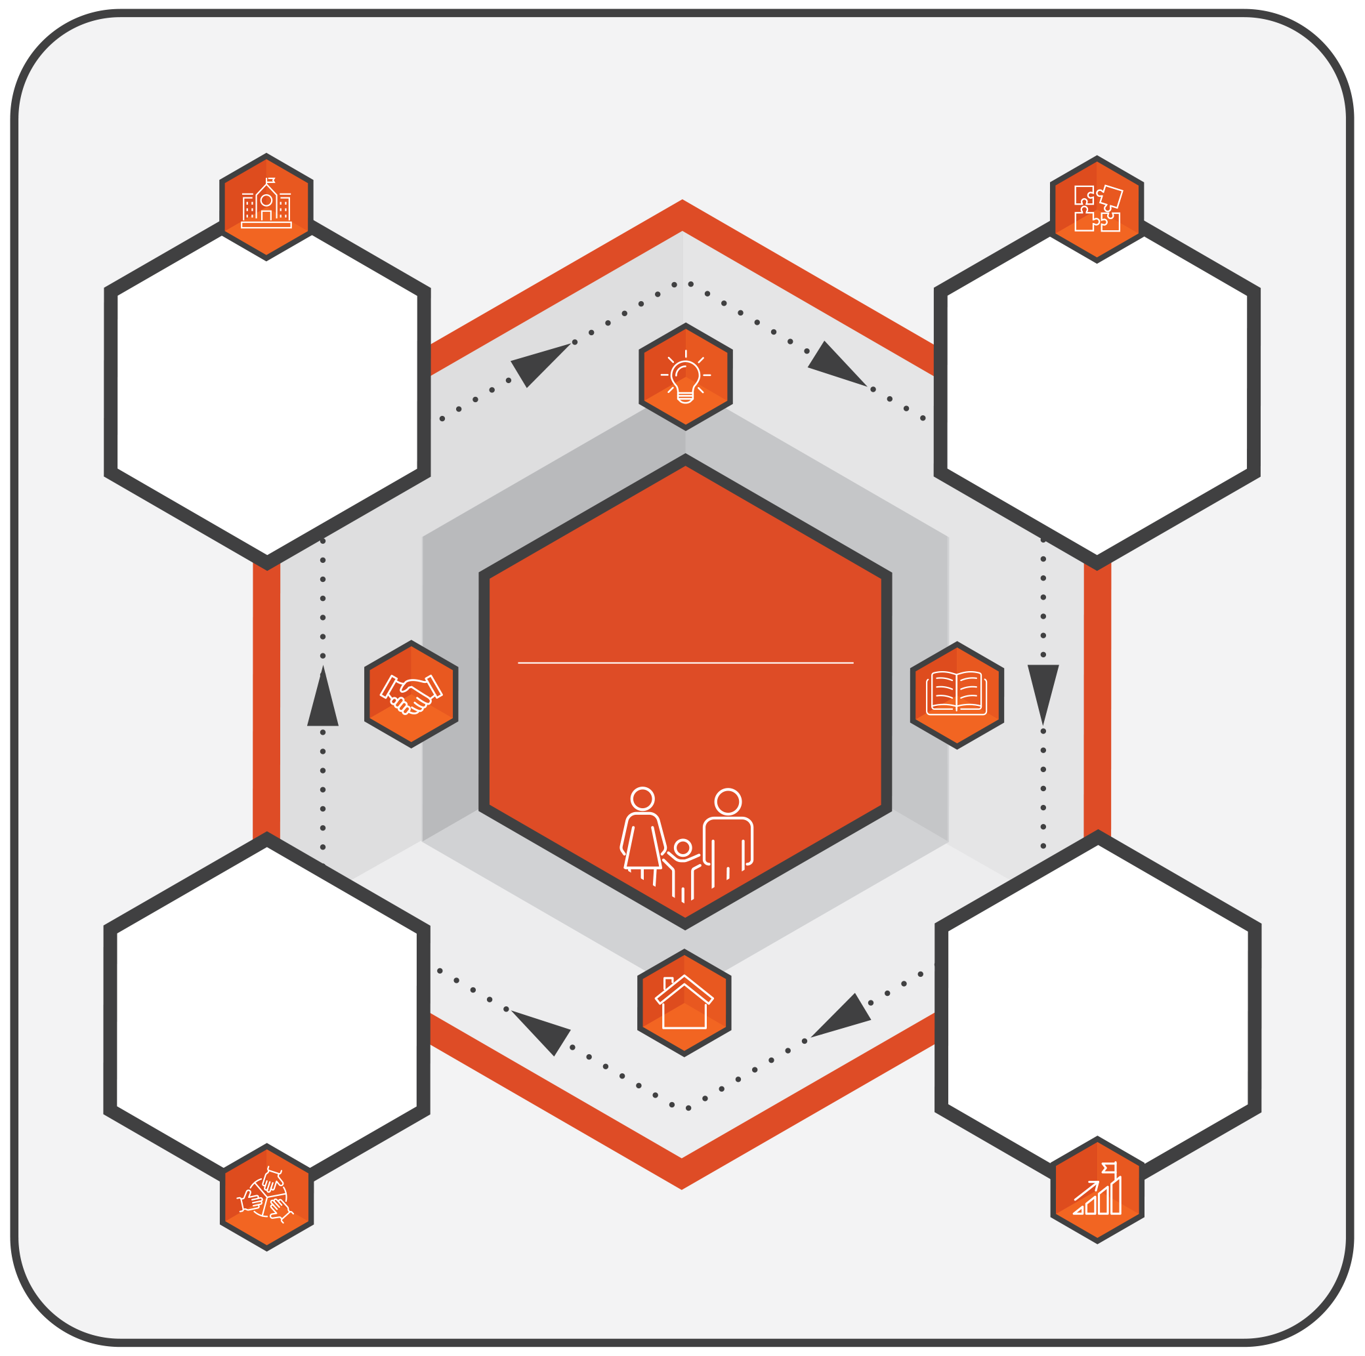
LFSA
LEARNERS AND FAMILIES SHAPING ACTION
EXPLORE CURRENT PRACTICES
How do partnerships work now?
FROM REFLECTION TO ACTION: STRENGTHENING PARTNERSHIPS
STRENGTHEN PARTNERSHIPS IN PRACTICE
Turning reflections into action
PLAN NEXT STEPS
What are realistic priorities for improvement?
IDENTIFY STRENGTHS AND GAPS
What works well and what needs strengthening?
Figure 3. Purpose of the tool


Community level
This section supports community partners, such as local services, non-governmental organisations, cultural groups, associations and grassroots initiatives, to reflect on their collaboration with schools, families, learners and education authorities. It explores how communities contribute to inclusion, well-being and learning, and how their knowledge and resources are recognised as part of the education ecosystem.
For example, a community organisation working with local families or young people may use this section together with a school to reflect on how they collaborate in practice: how roles are understood, how information and expertise are shared, and how joint activities (such as family workshops, mentoring programmes or after-school initiatives) are planned, supported and reviewed.
Similarly, a cultural mediator or community representative may use the tool with school staff to reflect on how they facilitate communication between families and the school, how cultural knowledge is recognised in school practices, and how emerging concerns are discussed and followed up.
Communities may use this section in full or in part, independently or in joint sessions with schools and ministries, adapting language and scope to reflect local realities.

Area 1: Awareness of rights, policies and shared commitments


Goal 1.1: Community organisations are aware of national and local partnership policies and rights frameworks
Guiding question   | Prompt(s)  (Optional cues to guide reflection) | Current status  (Please rate performance on each area using the scale provided below) | Comments/evidence  (Brief examples or references that support your answer, e.g. national policy text, law, strategy, consultation minutes, monitoring report)
1.1a Do community organisations know which national or local laws and policies define partnership in education and how these guide their collaboration with schools, families and learners? | Think of which policy or legal frameworks community organisations refer to when planning partnership activities.  Think of how these frameworks are shared or discussed in local meetings or networks.  Think of examples where policy awareness helped strengthen collaboration with schools or authorities. | 0 = Not developed  1 = Initiated  2 = Developing  3 = Established
1.1b Do community organisations exchange information with schools and other partners about current partnership priorities or initiatives? | Think of how schools or community partners share updates on partnership initiatives.  Think of whether information is shared in accessible ways for different groups.  Think of examples where regular exchange of information strengthened collaboration. | 0 = Not developed  1 = Initiated  2 = Developing  3 = Established

Goal 1.2: Community organisations share information about rights and participation with families and learners
Guiding question | Prompt(s)  (Optional cues to guide reflection) | Current status  (Please rate performance on each area using the scale provided below) | Comments/evidence  (Brief examples or references that support your answer, e.g. national policy text, law, strategy, consultation minutes, monitoring report)
1.2a Do community organisations work with schools to share information with families and learners about how they can participate in education partnerships? | Think of how information is shared (e.g. workshops, community events, social media, leaflets).  Think of whether this information helps families and learners understand their partnership role.  Think of examples where joint communication with schools improved family and learner engagement. | 0 = Not developed  1 = Initiated  2 = Developing  3 = Established
1.2b Do community organisations and schools co-ordinate to ensure that information about participation reaches families and learners who might otherwise be left out? | Think of joint actions that help to reach families or learners facing barriers to participation.  Think of how community organisations and schools review together who is being reached and who is not.  Think of examples of supports used (e.g. translation, community mediators, outreach visits). | 0 = Not developed  1 = Initiated  2 = Developing  3 = Established

Goal 1.3: Community organisations provide feedback to schools and ministries on how partnership policies affect local realities
Guiding question | Prompt(s)  (Optional cues to guide reflection) | Current status  (Please rate performance on each area using the scale provided below) | Comments/evidence  (Brief examples or references that support your answer, e.g. national policy text, law, strategy, consultation minutes, monitoring report)
1.3a Do community organisations collect and share feedback with schools and the ministry on how partnership policies work in practice locally? | Think of how feedback is gathered (e.g. community forums, surveys, joint reviews).  Think of whether feedback includes both achievements and challenges.  Think of examples where feedback led to changes in practice or policy. | 0 = Not developed  1 = Initiated  2 = Developing  3 = Established
1.3b Do community organisations communicate to families and learners how their feedback was used in discussions with schools or the ministry/decision-makers? | Think of how updates are shared (e.g. meetings, newsletters, online posts).  Think of examples where families or learners saw a change based on their feedback.  Think of whether communication is regular, inclusive and transparent. | 0 = Not developed  1 = Initiated  2 = Developing  3 = Established

Area 2: Community leadership, representation and decision-making

Goal 2.1: Community organisations are represented in local decision-making bodies related to education
Guiding question | Prompt(s)  (Optional cues to guide reflection) | Current status  (Please rate performance on each area using the scale provided below) | Comments/evidence  (Brief examples or references that support your answer, e.g. national policy text, law, strategy, consultation minutes, monitoring report)
2.1a Are community representatives actively participating in local education forums or partnership groups where priorities and actions are discussed with schools or local authorities? | Think of which local bodies include community representatives.  Think of how often they meet and whether community voices influence decisions.  Think of examples where community input led to joint actions or initiatives. | 0 = Not developed  1 = Initiated  2 = Developing  3 = Established
2.1b Do community representatives receive the information and preparation they need to participate effectively in these spaces? | Think of how agendas or materials are shared before meetings.  Think of whether briefings or orientation help new members to contribute meaningfully.  Think of examples where better information improved discussion or decisions. | 0 = Not developed  1 = Initiated  2 = Developing  3 = Established
2.1c Do community organisations ensure that representation in these local education or partnership bodies includes diverse voices, especially from marginalised or under-represented groups? | Think of which groups are currently represented and which might be missing (e.g. ethnic minorities, migrants, low-income families, people with disabilities).  Think of examples where outreach or rotation help to include marginalised voices.  Think of how decisions are reviewed to ensure they reflect the community’s diversity. | 0 = Not developed  1 = Initiated  2 = Developing  3 = Established

Goal 2.2: Community organisations co-ordinate among themselves to bring shared priorities to schools and educational authorities
Guiding question | Prompt(s)  (Optional cues to guide reflection) | Current status  (Please rate performance on each area using the scale provided below) | Comments/evidence  (Brief examples or references that support your answer, e.g. national policy text, law, strategy, consultation minutes, monitoring report)
2.2a Do community organisations meet or work together to agree on shared priorities before engaging with schools or authorities? | Think of how community groups plan together (e.g. networks, coalitions, joint statements).  Think of examples where co-ordination helped present a unified message or action.  Think of whether smaller or less-resourced groups were also included. | 0 = Not developed  1 = Initiated  2 = Developing  3 = Established
2.2b Do community organisations have clear ways to communicate their joint priorities to schools or the ministry and to follow up on results? | Think of how joint messages are shared (e.g. meetings, letters, reports).  Think of examples where shared proposals led to new co-operation or change.  Think of how follow-up or feedback is recorded and shared with members. | 0 = Not developed  1 = Initiated  2 = Developing  3 = Established

Goal 2.3: Community leaders promote equitable participation and model transparent governance
Guiding question | Prompt(s)  (Optional cues to guide reflection) | Current status  (Please rate performance on each area using the scale provided below) | Comments/evidence  (Brief examples or references that support your answer, e.g. national policy text, law, strategy, consultation minutes, monitoring report)
2.3a Do community leaders make sure that decision-making within their own organisations includes a range of voices and perspectives? | Think of how decisions are made (e.g. open meetings, rotating roles, surveys).  Think of which voices are missing and how they could be included.  Think of examples where inclusive leadership strengthened partnerships with schools. | 0 = Not developed  1 = Initiated  2 = Developing  3 = Established
2.3b Do community leaders communicate transparently with members about decisions, resources and partnership outcomes? | Think of how information on decisions or results is shared (e.g. meetings, minutes, updates).  Think of examples where transparency built trust within the community or with schools.  Think of whether members feel informed and able to ask questions. | 0 = Not developed  1 = Initiated  2 = Developing  3 = Established

Area 3: Resources and shared infrastructure for partnership

Goal 3.1: Community organisations have access to spaces, staff and resources to support partnership with schools and ministries
Guiding question | Prompt(s)  (Optional cues to guide reflection) | Current status  (Please rate performance on each area using the scale provided below) | Comments/evidence  (Brief examples or references that support your answer, e.g. national policy text, law, strategy, consultation minutes, monitoring report)
3.1a Do community organisations have access to spaces or platforms to meet and work with schools or authorities on partnership activities? | Think of the spaces or tools currently used for joint meetings.  Think of examples where having a shared space made collaboration easier.  Think of any barriers to access (e.g. transport, digital connectivity). | 0 = Not developed  1 = Initiated  2 = Developing  3 = Established
3.1b Do community organisations and schools plan together how available resources (staff time, communication tools, budgets) are used to support partnership work? | Think of how resource needs are identified and discussed with schools or authorities.  Think of examples where joint planning helped make better use of limited resources.  Think of whether there is a system to review how resources for partnership are used. | 0 = Not developed  1 = Initiated  2 = Developing  3 = Established

Goal 3.2: Resources are used equitably to reach under-served families and learners
Guiding question | Prompt(s)  (Optional cues to guide reflection) | Current status  (Please rate performance on each area using the scale provided below) | Comments/evidence  (Brief examples or references that support your answer, e.g. national policy text, law, strategy, consultation minutes, monitoring report)
3.2a Do community organisations and schools identify which families or learners face barriers to participation and plan how resources can support them? | Think of how needs are identified (e.g. attendance, feedback, local data).  Think of examples where resources helped remove barriers (e.g. translation, transport).  Think of how these decisions were made jointly. | 0 = Not developed  1 = Initiated  2 = Developing  3 = Established
3.2b Do community organisations monitor whether resource use is helping more families and learners to participate? | Think of how community organisations check who benefits from specific supports or initiatives.  Think of examples where adjusting resources improved participation. | 0 = Not developed  1 = Initiated  2 = Developing  3 = Established

Goal 3.3: Community organisations contribute local knowledge, volunteers or in-kind resources to partnership work
Guiding question | Prompt(s)  (Optional cues to guide reflection) | Current status  (Please rate performance on each area using the scale provided below) | Comments/evidence  (Brief examples or references that support your answer, e.g. national policy text, law, strategy, consultation minutes, monitoring report)
3.3a Do community organisations contribute local expertise, volunteers or materials that support joint activities with schools? | Think of how community members share skills or local knowledge (e.g. mentoring, cultural events).  Think of examples where volunteers or donations support partnership projects.  Think of how these contributions are recognised. | 0 = Not developed  1 = Initiated  2 = Developing  3 = Established
3.3b Do schools and community organisations plan together how in-kind contributions and local expertise complement funded activities? | Think of how shared planning helps balance funded and voluntary resources.  Think of examples where joint efforts expanded opportunities or reduced costs.  Think of how results or benefits are communicated to contributors. | 0 = Not developed  1 = Initiated  2 = Developing  3 = Established

Area 4: Learning from evidence and community insight

Goal 4.1: Community organisations collect feedback and participation data from families, learners and local partners
Guiding question | Prompt(s)  (Optional cues to guide reflection) | Current status  (Please rate performance on each area using the scale provided below) | Comments/evidence  (Brief examples or references that support your answer, e.g. national policy text, law, strategy, consultation minutes, monitoring report)
4.1a Do community organisations regularly gather feedback or participation data from families, learners and partners about how collaboration with schools works in practice? | Think of how community organisations collect feedback or participation data (e.g. surveys, meetings, forums, attendance lists).  Think of whether all groups have a chance to contribute, including those who are often marginalised.  Think of examples where collecting such data helped community organisations understand participation better. | 0 = Not developed  1 = Initiated  2 = Developing  3 = Established
4.1b Do community organisations store or summarise the information they collect so it can be shared and used to improve partnership practices? | Think of how feedback or data is recorded (e.g. notes, reports, spreadsheets).  Think of how confidentiality and consent are ensured when sharing information.  Think of examples where summarising results helped partners understand key findings and agree on next steps. | 0 = Not developed  1 = Initiated  2 = Developing  3 = Established

Goal 4.2: Community organisations analyse and discuss findings with schools and authorities to co-develop solutions
Guiding question | Prompt(s)  (Optional cues to guide reflection) | Current status  (Please rate performance on each area using the scale provided below) | Comments/evidence  (Brief examples or references that support your answer, e.g. national policy text, law, strategy, consultation minutes, monitoring report)
4.2a Do community organisations and schools meet to review evidence or feedback together and discuss what it means for partnership practices? | Think of how feedback or evidence is presented and discussed (e.g. review meetings, joint workshops).  Think of examples where joint discussion helped partners reach a shared understanding of priorities.  Think of how families and learners are invited to contribute to these conversations. | 0 = Not developed  1 = Initiated  2 = Developing  3 = Established
4.2b Do community organisations work with schools or local authorities to track whether agreed partnership actions are being implemented as planned? | Think of examples where community organisations and schools jointly followed up on agreed actions after reviewing feedback.  Think of how progress is recorded or communicated to partners.  Think of whether regular check-ins help maintain accountability and learning. | 0 = Not developed  1 = Initiated  2 = Developing  3 = Established

Goal 4.3: Community organisations share local evidence and insights with ministries and networks
Guiding question | Prompt(s)  (Optional cues to guide reflection) | Current status  (Please rate performance on each area using the scale provided below) | Comments/evidence  (Brief examples or references that support your answer, e.g. national policy text, law, strategy, consultation minutes, monitoring report)
4.3a Do community organisations share summaries or insights from local partnership work with the ministry/relevant decision-makers or wider networks? | Think of how findings are shared (e.g. reports, consultation meetings, regional platforms).  Think of examples where the ministry or networks used community organisations’ input to shape policies or supports.  Think of how community organisations prepare and present information to highlight both strengths and challenges. | 0 = Not developed  1 = Initiated  2 = Developing  3 = Established
4.3b Do communities communicate to families and learners how their local evidence or insights have informed broader decisions or policies? | Think of how updates are shared with families and learners after community or ministry meetings.  Think of examples where people saw how their stories or data led to wider change.  Think of how communication is kept simple, accessible and two-way. | 0 = Not developed  1 = Initiated  2 = Developing  3 = Established

Area 5: Building capacity and mutual learning

Goal 5.1: Community organisations develop their own capacity to engage effectively in education partnerships
Guiding question | Prompt(s)  (Optional cues to guide reflection) | Current status  (Please rate performance on each area using the scale provided below) | Comments/evidence  (Brief examples or references that support your answer, e.g. national policy text, law, strategy, consultation minutes, monitoring report)
5.1a Do community organisations provide or participate in learning opportunities that help members build the knowledge and skills needed to collaborate effectively with schools, families, learners and authorities? | Think of training, mentoring or peer-learning opportunities about partnership, communication or rights.  Think of examples where members used these skills to collaborate more effectively with schools, families, learners or authorities.  Think of whether learning opportunities are accessible to different community members (e.g. volunteers, leaders, youth). | 0 = Not developed  1 = Initiated  2 = Developing  3 = Established

Goal 5.2: Schools and community organisations create mutual learning opportunities
Guiding question | Prompt(s)  (Optional cues to guide reflection) | Current status  (Please rate performance on each area using the scale provided below) | Comments/evidence  (Brief examples or references that support your answer, e.g. national policy text, law, strategy, consultation minutes, monitoring report)
5.2a Do schools and community organisations plan and participate in joint learning activities (e.g. workshops, reflection sessions, peer visits or exchanges) to improve partnership practice? | Think of how joint sessions are organised and what topics they cover (e.g. communication, participation, equity).  Think of examples where shared learning led to new understanding or joint initiatives.  Think of how learning outcomes are shared with families or wider partners. | 0 = Not developed  1 = Initiated  2 = Developing  3 = Established
5.2b Do community representatives share their local expertise or experiences as part of joint capacity-building activities with schools or ministries/relevant decision-makers? | Think of examples where community members co-facilitated training or contributed case studies.  Think of how this exchange of experience improved mutual respect and learning.  Think of how schools or ministries recognise and integrate community knowledge into professional learning. | 0 = Not developed  1 = Initiated  2 = Developing  3 = Established

Goal 5.3: Community organisations support families and learners to build their partnership skills
Guiding question | Prompt(s)  (Optional cues to guide reflection) | Current status  (Please rate performance on each area using the scale provided below) | Comments/evidence  (Brief examples or references that support your answer, e.g. national policy text, law, strategy, consultation minutes, monitoring report)
5.3a Do community organisations offer activities or resources that help families and learners develop skills to participate confidently in education partnerships? | Think of workshops, peer groups or mentoring that help families and learners engage with schools.  Think of examples where these activities helped partners participate more actively in school life or decision-making.  Think of how schools and communities ensure these opportunities are accessible to all families and learners. | 0 = Not developed  1 = Initiated  2 = Developing  3 = Established
5.3b Do community organisations and schools evaluate together how capacity-building activities for families and learners are working and how they can be improved? | Think of how feedback is collected from families and learners after activities or training.  Think of examples where this feedback led to improvements in content or approach.  Think of how results are shared with the ministry to inform future capacity-building supports. | 0 = Not developed  1 = Initiated  2 = Developing  3 = Established

Area 6: Communication, trust and local co-operation networks

Goal 6.1: Community organisations maintain regular, two-way communication with schools, families and learners
Guiding question | Prompt(s)  (Optional cues to guide reflection) | Current status  (Please rate performance on each area using the scale provided below) | Comments/evidence  (Brief examples or references that support your answer, e.g. national policy text, law, strategy, consultation minutes, monitoring report)
6.1a Do community organisations maintain regular and open communication with schools, families and learners about partnership activities, events or concerns? | Think of how communication happens (e.g. newsletters, community meetings, online groups, informal visits).  Think of whether communication is two-way; not only sharing information but also listening and responding.  Think of examples where good communication helped prevent or resolve misunderstandings. | 0 = Not developed  1 = Initiated  2 = Developing  3 = Established
6.1b Do communities and schools review together whether communication methods reach all families and learners effectively? | Think of how communication tools or languages are chosen (e.g. translation, visual materials, digital and printed options).  Think of examples where community organisations adjusted how messages were shared to reach more families.  Think of whether partners discuss communication effectiveness during meetings or reviews. | 0 = Not developed  1 = Initiated  2 = Developing  3 = Established

Goal 6.2: Community organisations ensure safe, confidential spaces for families and learners to raise concerns
Guiding question | Prompt(s)  (Optional cues to guide reflection) | Current status  (Please rate performance on each area using the scale provided below) | Comments/evidence  (Brief examples or references that support your answer, e.g. national policy text, law, strategy, consultation minutes, monitoring report)
6.2a Do community organisations provide safe and confidential ways for families and learners to raise concerns, give feedback or seek support? | Think of what channels exist for families or learners to share concerns (e.g. confidential meetings, helplines, mediators).  Think of examples where issues raised were handled respectfully and led to positive outcomes.  Think of how confidentiality, trust and dignity are protected during communication. | 0 = Not developed  1 = Initiated  2 = Developing  3 = Established
6.2b Do community organisations and schools work together to address concerns raised by families or learners and follow up on outcomes? | Think of examples where schools and community groups jointly resolved an issue raised by families or learners.  Think of how follow-up or updates were communicated to those who shared concerns.  Think of whether families and learners felt listened to and respected throughout the process. | 0 = Not developed  1 = Initiated  2 = Developing  3 = Established

Goal 6.3: Community organisations collaborate with schools and local services to co-ordinate joined-up support
Guiding question | Prompt(s)  (Optional cues to guide reflection) | Current status  (Please rate performance on each area using the scale provided below) | Comments/evidence  (Brief examples or references that support your answer, e.g. national policy text, law, strategy, consultation minutes, monitoring report)
6.3a Do community organisations collaborate with schools and local services (e.g. health, youth, social care) to co-ordinate support for learners and families? | Think of examples where community groups, schools and local services worked together to support learners or families.  Think of how roles and responsibilities were agreed and followed up.  Think of whether collaboration is on-going or only occasional. | 0 = Not developed  1 = Initiated  2 = Developing  3 = Established
6.3b Do communities share key insights from local co-operation networks with the ministry/decision-making level platforms to strengthen wider co-ordination? | Think of how lessons from local partnerships are shared beyond the community (e.g. regional networks, ministry/decision-makers’ consultations).  Think of examples where such insights informed better co-ordination or new initiatives.  Think of how families or learners are informed about these wider developments. | 0 = Not developed  1 = Initiated  2 = Developing  3 = Established

